Zeppelins & Aerophilately


A Brief Note
We are pleased to offer you our new listing of Zeppelins and Aerophilately. This list is only a small part of our Aerophilately stock. If you don’t see what you are looking for - please ask! Strongest in Worldwide Zeppelin flights, this list includes rarities as well as U.S. and Worldwide DO-X, Catapult Balbo flights, etc. As items are virtually all are one-of-a-kind, we suggest ordering early to avoid disappointment. If possible, a list of alternates is appreciated. Time payments are possible. However, with the specialized nature of this list, discount plans such as the Monthly Purchase Plan are not applicable.
Photocopies of any item will be sent, emailed or faxed on request. Or see our web site at www.hgitner.com for color photos of every item!
All covers not otherwise described are in F-VF or VF condition. As always, SATISFACTION
GUARANTEED!

Dates
The date listed in the description for covers is usually the earliest postmark date on the cover. The actual flight date may be later.

Abbreviations:
VF = Very Fine
XF = Extra Fine
FDC = First Day Cover
PPC = Picture postcard
S. Am. = South American
N. Am. = North American
S. = Sieger catalog
Mi = Michel catalog
€ = Euros
1 Euro = $1.1
defins = definitive stamps
ovpt. = overprint

Afghanistan
07931d 1933 4th South American Flight. Sent via Turkey to Brazil (S.223 B) $3,900.00

Albania
12051 C8 - C14 F - VF LH + NH Slight toning cv
39.50 $25.00

Algeria
07934d 1933 2nd South American Flight sent to Brazil S.214Aa $575.00

Argentina
35021 1930 #C24 Hinged Mint XF Signed Stolow Cat Value: $200 $140.00
07593 1930 C25 - C29 H Set 1930 Zeppelin Overprint in Green $600.00
05204 1930 C37 F-VF LH 90c single $25.00
05206 1932 C35 - C37 Muestra (specimen) Overprint $50.00
05203 1932 C35 - C37 VF LH $40.00
36142 1932 (Feb 27) Airmail Cover from Crash in Brazil. Caught in a storm in Brazil, the plane was struck by lightening. Crash mail was found in the sea and stamped "Damaged by sea water". 3L. D2 27e Sfr.300. $200.00
27952 1937 (Jun 9) Lufthansa Flight Card sent registered to Sieger in Germany. Attractive card. $75.00

Australia
21281 1934 (Apr) 1st t Official Air Mail Australia - New Zealand ,backstamped Auckland and addressed to London, England. $75.00
21282 1934 (Apr) 1st Official Air Mail Australia - New Zealand, backstamped Plymouth, addressed to Palmerston North, New Zealand. $75.00

Austria
03040 1930 (Aug 5) Catapult card, "Europa” Bremen to New York. Trial flight with C13 + C25 x3 franking. Red straight-line precursor cachet "Koln Katapultflug D. "Europa" Bremen - New York". K39AU cv $400.00 Hab. 0029 $275.00
03399 1930 (Apr 23) England Flight PC. Vienna - Friedrichshafen, dropped at Orly S.55c $425.00

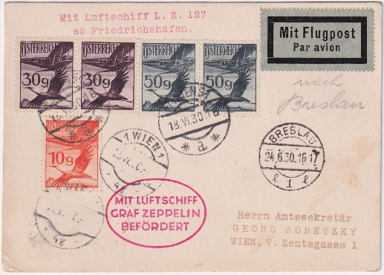
Item 03595 Austria 1930 Schlesian Flight
03595 1930 (Jun 18) Schlesien Round Flight Postal Card. Friedrichshafen dropped over Breslau w/ receiving cancel. S.69 $500.00
11554d 1931 Zeppelin Flight B87, B88, B90, B92 Rotary $1,750.00
11555d 1931 Zeppelin Flight w/ B89, B90, B92 Rotary $750.00
11556d 1931 Zeppelin Flight w/ B87 - B92 complete Rotary Set $1,000.00
11557d 1931 Zeppelin Flight w/ B87 - B92 complete Rotary Set $1,000.00
11558d 1931 Zeppelin Flight w/ B87 -B92 Complete Rotary Set $600.00
03039 1932 (June 22) Catapult cover "Europa" to New York sent by registered mail to Costa Rica. Stamped "Received in ordinary mail N.Y.P.O. Varick S" Backstamped Berlin, New York and Costa Rica on reverse. K111AU cv $800.00 Hab. 89 $750.00
21491 1933 (Jul 10) WIPA Glider Flight Card with 7 airmails. $45.00
36618 1933 (May 14) Glider Flight Graz - Maribor, Marked Unknown address & Return to Sender. F-VF $40.00
08138d 1934 "Bremen" Catapult Registered. Postage paid in cash. (k207cAV $900) 8 carried $650.00
01764 1950 (May 17) UPU, #565-67 air label on VF flight cover to US. Mi DM110 as used!
$40.00
01766 1952 VF Balloon Post cover to Switzerland. Spelterini vignette with Bird airmails + 3g and 30g stamps on top. Ank K-S IId oS 4700 $200.00
01765 1955 (Oct 8) C54, C57 + 30g on XF Airmail cover to US. Shrub Oak, NY local post (Dog post) triangular stamp tied upon receipt (for delivery from Post Office to house) Triangular stamp also ties Austrian Stamps! Mi DM 387 for Austrian stamps only! $200.00
01763 1961 (Sept 9) Rocket Mail cover with violet rocket mail vignette in Souvenir Sheet of 4, imperf. Red flight cachet. Small stain at right, otherwise VF $25.00

Bahamas
02849 1919 (Jan 29) First Flight from Nassau to Miami. The return address is the Royal Bank of Canada. Violet 2 line cancel "Air Service Nassau to Miami", backstamped Miami on reverse. Rare item in good condition! $300.00

Belgium
07994d Belgium / Colombia 1931 SCADTA Flight Cover $375.00
14572 1931 (May 10) Europa catapult cover to New York. K61 BE, Belgium unlisted $800.00
15677 1939 (Apr 13) Early blue airmail cover sent to Prague, Czechoslovakia. Slit open at the bottom. $30.00
12964 Belgium Flemish Legion Mi V-VIII VF NH 1943 set with airplane overprint $325.00
20420 Belgium Mi IX - XIV Flemish Feldpost F - VF Mint NH cv $290 $140.00
15050 1944 Belgium Mi XV - XIX 1944 Flemish Feldpost Wapen SS prepared for sale but never issued cv €1000.00 $495.00
01771 1946 (Sept 7) Aviation Day card with special postmark $25.00
01772 1946 (Sept 7) Aviation Day card with special postmark. $25.00
04108 1960 Souvenir card Airmail to Congo, Scott B669-71 VF Mint $60.00

Benin
01605 1977, C265 80f signed proof in red. Concorde supersonic plane. $200.00
01604 1977 C266 150fr Signed proof in violet. 150f Zeppelin. $200.00

Bolivia

34992 1930 #C24 Used VF cv: 80 $60.00
06094 1930 C24 - C26, C24a - C26a VF H $500.00
05210 930 C24a Ave, LH tete beche pair $300.00
05212 1930 C25 F-VF LH $65.00
05214 1930 C25a Fine LH Inverted ovpt $150.00
25422 1930 C13 VF LH Brown overprint on 10c vermilion. PF certificate. cv $2500. $1,900.00

Brazil
03858 1928 (June 7) Early airmail cover sent to Ottoman Bank, Constantinople, Turkey! Neat vertical fold down center. $135.00

Brazil 1930
15524 1930 (May 24) Zeppelin Flight on VF Card, S.59A. Unusual shaped post card. $100.00

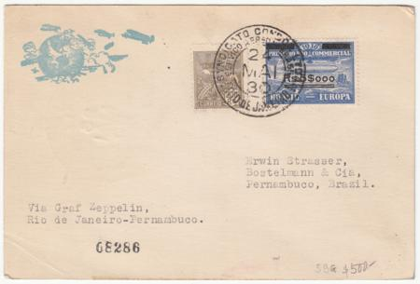
item 15526 Brazil 1930 Flight Card
15526 1930 (May 2) Zeppelin Flight Card with 500Rs on 20,000 and nice printed cachet in blue. VF except for card corner crease on lower left. $225.00
15532 1930 (May 28) Zeppelin VF Flight Cover to NY, S.59B/59E but with wrong un-overprinted stamp. $135.00
15845 1930 Zeppelin VF Flight Cover to Germany. Slight stains at bottom edge. S.59B $95.00
16007 1930 (May 24) Zeppelin Flight on PPC to Lakehurst, Inverted Date in Rio Cancel. Error €125 + 100% = €250 $175.00
16563 1930 (May 24) Brazil Zeppelin Flight on Roessler cacheted Card to US. The un-overprinted stamp used in error, it's also possible the 10,000rs was used in error on this card. The card has a few flaws. S.59B/59E $150.00
16564 1930 (May 24) Zeppelin Card to Lakehurst Cancel Date Inverted Error €125 S.59D $175.00
16565 1930 (May 24) XF International Flight the no to USA on Roessler Bordered Cover. S.59D Beautiful! $140.00
16566 1930 (May 24) Zeppelin Card to USA with Rotated date in Cancel, unlisted in Sieger. S.59D $150.00
16569 1930 (May 24) Zeppelin Flight Cover Rio to Lakehurst. Cancel is rotated date, unlisted variety. S.59D $150.00
16585 1930 (May) Zeppelin Flight Card to U.S.A., Rare Bahia Origin. Lakehurst backstamp. Some tropical spots front and back. $150.00
19914 1930 (May 30) Home Flight with 5,000Rs on 20,000Rs Zeppelin Stamp. S.59G $150.00
20436 1930 (Jun 6) Zeppelin Flight Cover, Rio - Friedrichshafen, with 10,000r Zeppelin overprint stamp. Signed by President Getulio Vargas. Horizontal crease at bottom of cover as well as small condition flaws. S.59H €300 $200.00
36123 1930 May 24) Zeppelin Flight Cover with 10,000 overprint USA, Rio de Janeiro to Lakehurst . Green Lakehurst backstamp. S.59E €100 $100.00
42591 1930 #4CL3 NH XF Zeppelin cv: 175 $110.00
42888 1930 4CL1-3 LH VF Zeppelins cv 257.50 $150.00
42894 1930 4CL1-3 Mint/Used F-VF Zeppelins cv 152.50 $80.00
42587 4LC5 LH Mint VF-XF Zeppelin cv: 225 $180.00
42589 4LC5 LH Mint VF Zeppelin, small tear LL cv: 225 $45.00
42585 4CL5 Used VF - XF Zeppelin cv 300. . $180.00
42618 #4CL6 Used F - VF Zeppelin cv 90 $60.00
42616 4LC8 LH F - VF lower corners crease Zeppelin cv: 135 $25.00

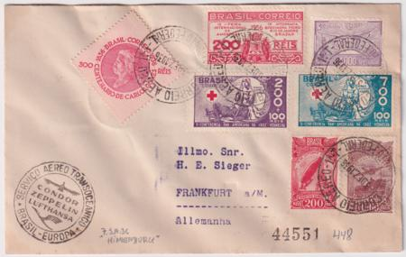
item 28012 Brazil 1937 Flight Cover

Brazil 1931-1941
19676 1931 (Sep 22) 2nd South American Zeppelin Flight Cover to Germany, S.130C €50 $60.00
20435 1931 (Sep 1) 1st South American Flight Cover with both Zeppelin Overprint Stamps and black flight cachet. Addressed to Sieger. Some light wrinkling on reverse S.125C €115 $85.00
20437 1931 (Sep 24) 2nd South American Zeppelin Flight Cover to Germany, S.130B €75 $85.00
27954 Brazil 1932 (Oct 17) 8th South America Zeppelin Flight to Zurich, Switzerland. S.190 $35.00
28265 1932 (Oct ) 8th South America Zeppelin Flight to France and then forwarded on small airmail cover S.190 $40.00
27955 1933 (Aug 9) 4th South America Flight Card. Registered airmail cover to Switzerland. $35.00
27975 1934 (Dec)12th South American Flight Cover addressed to Stoltz via Rio de Janeiro to Recife. S.287Ac €200 $135.00
28007 1936 (May 29) Hindenburg 2nd South American Flight Card sent registered to Sieger in Germany. $45.00
28009 1936 (Jul 24) Hindenburg 3rd South American Flight Cover sent to Sieger in Frankfurt, Germany. Attractive franking. S.426A $40.00
28011 1936 (Dec 3) Hindenburg 7th South America Flight with Beautiful franking sent to Sieger in Germany. S.448 $70.00
28012 1937 (Jun 10) 250th Condor-Lufthansa Flight Cover, violet flight cachet and special Frankfurt cancel. Muller 247 $180.00
27695 1941 (Aug 22) Unlisted Crash Cover stamped "Accidente de Aviao". Vertical fold down center. $225.00
36610 1942 C47a VF NH Corner Margin Block of 4, Good wmk Variety. cv $900 as LH $450.00

British Somaliland
07935d 1933 8th South American Flight sent to Brazil S.235Aa $2,250.00
07981d 1933 Chicago to Peru S.238Aa $3,000.00

Bulgaria
08012 1933 3rd South American Flight S.219B $500.00

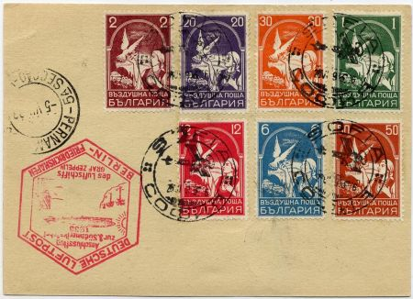
item 13013 Bulgaria1933 3rd SA Flight
13013 1933 (Jun) 3rd South America Flight 216 l postage on front and back including C5-11. Berlin connecting flight on 1 l postal card. $550.00
35280 1991 #3613 Ariane Rocket Imperf Color Proof, Europa with 1998 certificate from Bulgarian expert. $75.00

Cameroun
01798 1918 (Aug 23) Two small sized registered covers with #130, 131, 133, 134, 136-141, sent to Birmingham, England. $115.00
01660 1977 Artist Die Proof: Scott C249 300fr Signed proof in black picturing the Concorde. $250.00

Canada
13146 1925 (Jun 27) CL5 on 1st Flight Haileybury Rouyn signed by pilot B. W. Broatch, Slight stains on bottom of cover $75.00
12919 1926 (Aug 11) Haileybury Rouyn VF Flight cover with CL10a signed by the pilot, Glyn R. Burge. $225.00
12976 1926 Two VF First Flights Haileybury – Rouyn and return, Both with CL11 and signed by the pilot. $150.00
12977 1926 (Aug 12) Rouyn – Haileybury VF Flight Cover with CL10 signed by the pilot. $175.00
36612 1926 CL9 Semi-Official Airmail VF NH Block of 4, some spilt perfs. $95.00
36613 1926 CL9 Semi-Official Airmail VF NH Block of 4 $140.00
36620 1926 (May 24) CL9 on Registered Commercial Cover Red Lake to Winnipeg. Minor stamp stain from postmark. Scott cv $500. as commercial $150.00
36621 /US 1926 (Aug 28) CL9 to Haileyburg and then returned to Buffalo. US 2c # 634 and Canada CL9. Unusual mixed franking! cv $500 for non First Flight $200.00
27696 Canada/US 1927 (Jun 18) US C10 Unofficial Chicago FDC on Canada 2c Entire. Chicago and Windsor, ONT. pmk dated June 18. $275.00
16645 1928 C1 VF NH, natural gum skip. $9.00
10635 1928 (Mar 9) VF Cover, CL 43 Flight, Gold Pines to Sioux Lookout. Scott cv $225.00 $140.00
12918 1928 (Mar 9) Jackson Sioux Lookout VF airmail cover with CL43, Patricia Airways Lmtd label and signed by the pilot, Charles Sutton. $175.00
20087 1928 (Sept 5) Special Trans-Canada Flight Ottawa - Vancouver, Signed by Squadron leader Pilot A.E. Godfrey, RCAF. 300 flown. $75.00
19645 1929 (May 31) CL47 Grande Prairie to Edmonton Commercial Airways Cover. cv $100. + $75.00
17341 Canada / Germany 1930 (Apr 24) Zeppelin South America Flight Cover addressed to Chief Postmaster in Friedrichshafen with 5 stamp Canadian franking and Germany C38, 2m Zeppelin. This legal sized cover has been cancelled as follows: Regina, Sask, Apr 24; Montreal Apr 28; Friedrichshafen May 13, Germany On Board cancel May 19 and Seville May 19. $1200.00
19880 1930 (Jul 23) First Flight with CL49, 10c purple Semi Official, Edmonton - Ft. McMurray, franking C1. Scott cv $250. $150.00
12903 1932 Early Airmail cover,192-194 FDC signed by the Postmaster with Roessler cachet. $50.00
20111 1934 (May 21) 1st Flight Ile a La Crosse - Prince Albert Signed by Pilot W. E. Catton $10.00
08129 1936 (May 18) 2nd N. Am. Hindenburg Flight S.411C. VF registered cover was sent to Sieger in Germany. $525.00
08106 1936 Hindenburg Flight to France S.409G $750.00
08130 1936 2nd North America Flight S.411C (R#1231) $500.00

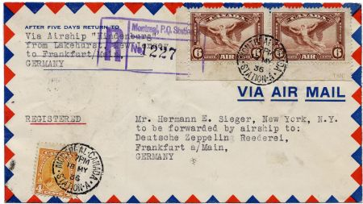
item 11687 Canada 1936 2nd NA Hindenburg
11687 1936 2nd North American Hindenburg Flight, VF registered airmail cover sent to Sieger in Germany. $525.00
13153 1936 (May 7) VF Hindenburg 1st N. Am. Flight to Switzerland with 176, 220, 223 and C5. Legal sized airmail cover. $525.00

Central Africa
01669 Scott 93 Artist Die Proof of Douglas DC3 in magenta. …$175.00 $140.00
01668 Scott 94 Artist Die Proof of Beechcraft Baron in magenta… $200.00 $160.00
01667 Scott 95 Artist Die Proof of Douglas DC4 in blue…$175.00 $140.00
01664 Scott C47 Artist Die Proof of Junker 52 in brown…$200.00 $160.00

Chad
01688 1977 Artist Die Proof: Scott C215, signed proof in brown of the Concorde $250.00

China
05265 1921 C1 - C4 VF LH - over great wall, partial set $135.00

Colombia
09484 circa 1920 SCADTA Set of 2 Large Unused Postal Stationary Envelopes, 30c and 50c. In VF condition except for a couple of small, minor toning spots. Also included (but counted in the price) is a 20c unused letter sheet with toning spots $500.00
28578 c.1923 Used SCADTA Consular Overprints "H, I and P". Columbia 30c one with Netherlands and one Italy overprints F-VF. Colombia 15c with Panama overprint with faults. $12.50
28579 circa1923 Used SCADTA Consular Overprints "EU" overprints F-VF. Colombia 15c with Panama overprint with faults. $22.00
28340 Colombia /US 1924 (Jan 10) CLEU 43 60c pair with violet "EU" Inverted on one stamp. 12ct Colombian stamps paying 4x the rate on legal cover from "Huth & Co., NY” sent to Manizales, Colombia. Slight edge toning. A great rarity. Originally $4000 now. $3,000.00
28341 Colombia / US 1924 (Jan 4) CLEU 43 60c pair + CLEU48 (30c on 20) + additional 15c paying 5x the rate. Violet handstamps. Legal size cover from Huth & Co, NY to Manizales, Colombia. Some edge toning and roughly opened at the top, not affecting stamps. Was $1,000. $750.00
28435 Colombia / US 1926 (May 29) Colombia Airmail . Corner cover from Winston Bros. Co. Constructors in Minnesota. Dual franking with green airmail vignette "from Barranquilla via Colombian Air Mail". Some toning. $100.00
28577 1926 (Apr 19) SCADTA Consular Ovpts "GB" on Cover Sent Airmail. 20c, 30c and 1p with ovpts, Scott CLGB 54, 55 and 58 + Colombia 372 strip of four on cover missing back flap, slight toning. $275.00
03769 Colombia / Germany 1927 European sized blue airmail cover with dual franking. Sent registered from Hamburg, Germany with 70pf metered postage to Colombia. Two SCADTA stamps added, 20c and 60c with machine overprint "A". The 20c has red "R" overprint added $400.00

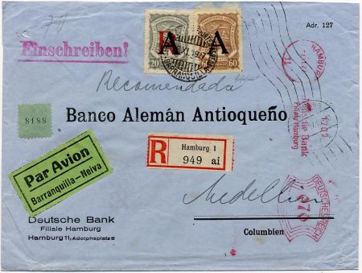
item 03769 Colombia/Germany 1927 Cover
28342 Colombia / US 1927 (Sep) Colombia Airmail Corner cover from Winston Bros. Co. Constructors in Minnesota. Dual franking with green airmail vignette "from Barranquilla via Colombian Air Mail". Some edge toning and roughly open at left. $65.00
28647 1928 Full miniature sheet of 25 CLEU62, 30c SCADTA Consular Overprints "EU" overprints Type ll in VF NH condition. A few separations at bottom selvedge. cv $250. $125.00
07965 Colombia / Germany 1929 South American Flight S.26B $750.00
05316 C68 - 79 F - VF LH $100.00
27698 Colombia / US 1927 (Sep 14) SCADTA Cover to US with special delivery stamp,US E12. Addressed to Fort Worth Texas and two-line rubber stamp: "Fee claimed by office of first address". Vertical crease down center. $150.00
27697 1931 ((Apr 3) First Flight to Cristobal, Canal Zone. Addressed to Colón Panama. Horizontal crease at top, not affecting stamps. $75.00
27699 1931 (Jun 15) 1st Flight from Bogota to NY via Barranquilla -Kingston. Flight cachet and colorful 6 stamp franking. $60.00
22599 1933 (Dec 13) C102, E1 on Airmail Cover to Cleveland OH from the German Consulate in Manizales. Faint 3-line “Por Avion, Correo Aereo, Mancomun" on left. Barranquilla air transit backstamp on reverse, Dec 16. E1 is rare on cover, cv $150 as used. $250.00

Costa Rica
14859 1950 C186-8 on registered airmail cover signed by pilot Clarence A. DeGiers $20.00

Cuba
41402 1927 (Oct 28) First Passenger Service Flight Cover From Havana, Cuba to Key West, FL Signed by Pilots Hugh Wells & Edwin Musick. $100.00

Czechoslovakia
42937 1913 Brünn Exhibition Vignette with Airship for Inventions and Patents, Mint. $25.00
39138 1945 (May 12) Stamp Sheet Signed by President Edvard Benes. Sheet has Scott 266, 268 and 269 tied by a May 5 cancel. Tear in top right corner. $175.00

Danzig
14571 Danzig / US 1931 (May 19) Bremen Catapult cover to New York with mixed franking. New York G.P.O May 27. Cover has center vertical crease from being folded. K63 DZ $600.00

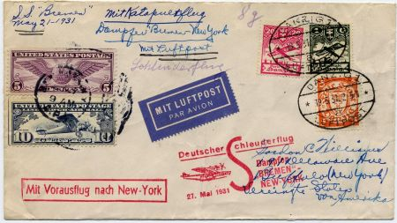
item 14571 Bremen Catapult Cover to NY
15531 1923 (Jul 4) Airmail Postal Card, Berlin - Danzig. $25.00
16568 1931 (Jul 21) Zeppelin Polar Flight Card to Ship Leningrad. VF card with all postal markings on face S. 119 €900 $600.00
08115d 1936 Unlisted 5th North America Flight $500.00
08116d 1936 Unlisted 6th NA Flight $500.00
08122d 1936 3rd North America Flight $375.00
36120 1934 (Sep 15) 8th S.Am.Zeppelin Flight to Brazil. sent registered. S.(274) $125.00

Denmark
24755 1929 Early Airmail Cover from Copenhagen, Denmark - Bratislava (Pressburg) Czechoslovakia. Small, neat cover with C1 and C2 (X2) with Berlin transit cancel and airmail label. Bratislava backstamp $110.00
08013d 1932 5th South American Flight sent to Brazil S.171Aa $400.00
22594 1932 (Mar 19) First South American Flight Friedrichshafen - Pernambuco with C2 and additional 55o cancelled Copenhagen. Zeppelin and Berlin connecting flight cachets. Addressed to Concepcion, Chile. Backstamped Santiago Mar. 28. S.138 €650. $450.00
27700 1932 5th S. Am. Flight sent from Sieger to H. Stoltz in Brazil with C1 and C5. $400.00
08132 1933 C3, C5 Registered Catapult 7 carried (K143 DK $1000) $875.00
16070 1933 (May 6) Catapult Cover, Europa - NY. Only 5 flown! K137 cv $600. $500.00
15662 1934 (Jun 4) Catapult Cover, Bremen - New York. Registered cover is addressed to NY, NY and has 2 airmails and 1 additional. K183 $300.00
21509 1934 (May 18) Catapult Cover, Bremen - New York. Three airmails + additional definitive Addressed to Rahway, NJ. K179 €350. $300.00
18068 1946 Burned Newspaper Recovered from Air France's Copenhagen to Paris First Flight crash. Newspaper addressed to Paris. All crew members were killed on the flight. $250.00

Dominican Republic
08113 1936 Hindenburg 3rd North American Flight with certificate. Unlisted; minor flaws. $1,750.00

Egypt
05218 1933 172 - 176 F-VF LH Aviation Congress $50.00
05216 1933 172 - 176 F-VF NH Aviation Congress $100.00

Estonia
07969d 1933 Chicago Flight to U.S. S.238E $675.00

Finland
05221 1930 C1 F-VF NH $185.00
12042 1930 C1 VF LH cv 125.00 $85.00
12043 C1 F - VF LH cv 125.00 $70.00
07998 Finland / Liechtenstein 1931 (May 28) dual franking on Vaduz flight. Liechtenstein C7 tied by Zeppelin postmark. Addressed to Lausanne, Switzerland. S.110A unlisted variety. $3,250.00

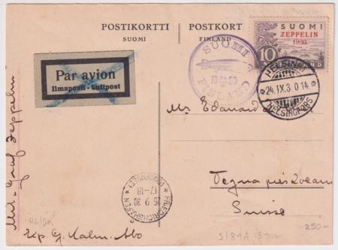
item 28314 Finland Baltic Sea Flight
28314 1930 (Sep 24) Baltic Sea Flight Card with One Zeppelin Stamp. Addressed to Switzerland. S.89A $250.00

France
42938 1898 International Exposition of Dijon Vignette in blue with Air Balloon. Mint $15.00
42939 1910 Ruinart Père & Fils Cup Vignette with Biplane over English channel. $30.00
42940 1910 Ruinart Père & Fils Vignette with Bleriot XI Monoplane over the English channel. Mint, no gum. $35.00
42941 1910 Circuit L’est Vignette, Early Aviator Competition, Mint no gum. $20.00
42942 1912 1st Grand Prix of Aviation Vignette, Angers. Mint $20.00
01806 1916 WWI 71st Flying Squadron gummed vignette, vertical format. Biplane $39.00
01807 France WWI Squadron MF 72 gummed vignette in black, vertical format. Bi plane. $39.00
01809 1916 WWI Martinique Aviation, Le Havre gummed vignette in light blue, pink and black. $35.00

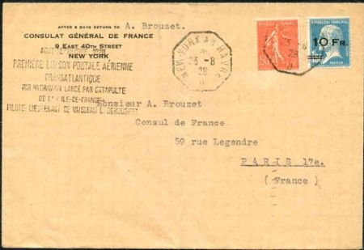
item 03945 France 1928 Ile de France Flight
03945 1928 (Aug 23) Ile de France Flight cover with C4 addressed to French Consulate in Paris, properly backstamped. C4 is centered slightly to the right. Lightly folded down center, otherwise in pristine condition! Maury catalogue value €13,000 $8,500.00
20406 1930 (Aug 8) Inter Air Post Exhibition Cover to Casablanca. Registered cover has special cancel and backstamp for Exhibition. Tiny tear at top edge $45.00
06375 1934 (June 4) sent from Correil to Saigon Indochina. Stamped "lettre transportee Exceptional ement par avion a titre de propagande" $25.00
01813 1935 (Jun 8) Commercially used Air France airmail cover from Le Havre sent via Air France to San Paulo, Brazil. Backstamp on reverse. Slit open at right. $75.00
02852 1936 (June 15) First Flight card Vichy - Bourges, Philatelic Exhibition of Berry illustrated card with vignette. Bourges receiving cancel on address side. $50.00
01815 1938 (Nov 6) Haudroy 20th Anniversary postal card with commemorative cachet and label $25.00
42840 1945France Nice Anciens de L'Aviation 1945 Yv1-2 LH VF €180 $95.00
06370 1946 Deluxe Proof of the Berck imitation of C15. Small tear on top edge + blue label "salon de la philatelie" 1946 with commemorative cancel Owner paid retail of $190 $40.00
17368 1947 (Mar 14) Air France "Dakota" Crash Cover, Nice-Paris, Crashed Vercors with crash label affixed. Also included is a cover from the same date. Nierninck 470314b sfr. 800 $300.00

French Area
08762 French Guiana CL1 Used F - VF Signed Sanabria. Pristine! cv $1600. $1,200.00
08763 French Guiana CL3 Fine Used on piece Signed Sanabria. faults at UL, but still a great airmail rarity. $325.00
24267 French Guiana 1920 (Jul 12) Cover with CL5, 75c T.A.G. semi-official airmail with La Société des Transport Aériens Guyanais domestic use, prepaying the internal airmail fee from Saint Laurent du Maroni to Cayenne. Only 500 of this stamp issued on July 8. Stamp is VF with four margins, completely sound unlike most examples we have found. Nicely tied by less common sans-serif Avion large box cancel. Slight cover flaws in UL as seen in photo. Cover lightly folded not affecting stamps or postmarks. cv $1750. $975.00
08014d French Indochina 1934 1st South American Flight Saigon to Paris, then sent to Brazil S.247Aa $1,875.00

Ballon Monté List!
Special pricelist now available for France Ballon Monté complete with brief history about the era and each balloon. Ask for your free copy!

Germany

Germany 1895-1919
08096 Germany / Mexico 1895 SS Elbe Shipwreck to Mexico $500.00
39015 1908 B & W Photo Card of Graf Zeppelin Portrait $20.00
05226 1912 Mi. l-lll F - VF Used Unlisted in Scott - Rare $250.00
08102 1912 Viktoria - Luise Card S.4X $375.00
14761 1912 (Jun 21) Early airmail card with single franking from Worms and 30pf semiofficial airmail Rare! S.12 $425.00

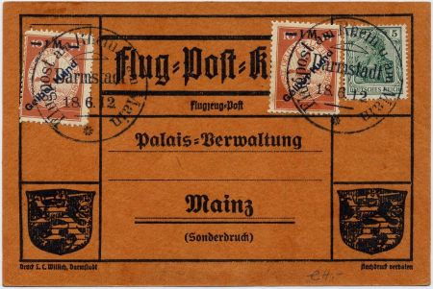
item14763 Card with 1m Gelber Hund Error
14763 1912 (Jun 18) Airmail postal card with 1m Gelber Hund overprint, Mi lV and 1m Gelber hund error overprint, Mi lVf $450.00
28036 1912 National Flight Donation Post Card, unused, with Matching Vignette. Pictures a Prussian prince and aircraft. $30.00
42115 1912 Volksfest Straubing Aviation Meet Vignette, Mint No Gum $15.00
42120 1912 Gordon Bennett Stuttgart Aerophilately Vignette depicting Balloons and Zeppelin, 4 different colors: Orange & Dark green,Blue grey & Black,Green & Light green, Pink & Blue, Each priced @ $25. or all for $85.00
42121 1912 Flug am Oberrhein, Early Flight Meet Vignette, 1st printing. NH $35.00
42122 1912 Munich, Viktoria Luise Airship Vignette, mint $30.00
42897 1912 Vignette for Aviation Week, Biplane over Nuremberg $20.00
42901 1912 Vignette Berlin -Vienna Flight, embossed poster stamp in red Mint $20.00
42914 $75.00
05228 1913 Mi Vl F-VF LH, signed Mulhausen Semi-Official Air Vignette Mi 1200 $750.00
42904 1913 Zeppelin over Frankfurt Vignette, advertising poster stamp for Male Choir Competition $20.00
24516 1914 (May 11) First Flight Card Leipzig - Dresen, 25pf postal card. €50 $35.00
24517 1914 (May 11) First Flight Card Dresen - Leipzig on 25pf postal care. Mi €75 $60.00
24504 1915 (May 23) Military Flight Card - Photo Card, Armeekorps Feldpost marking and boxed Feld - Fleiger handstamp. Some toning spots on card. $190.00
24520 1915 (Sep 6) Military Flight Cover, Feldpost cover with Red Feldflieger Handstamp on reverse over flap. Scarce marking. $90.00
28037 1915 Bavarian Flying Corps. Cover with Feldpost Cancel and violet corp handstamp. Scarce cover. $150.00
24519 1916 (Dec 7) Early Flight Photocard depicting aircraft and personnel. Marked as Feldpost $25.00
28070 1916 (Feb 16) Early Photocard with Aircraft, cancelled Neudorf. Violet "Armee flugpark, Brief Stempel" $65.00
05571 1917 Piece of German Zeppelin Cloth - approximately 35x35mm $29.95
36365 1918 Photo Card mounted on card and signed by Peter Strasser, head of German WWI Naval Zeppelins. $75.00

Germany 1920-1923
16591 1921 First Official Airmail issue on Unflown Glider Meet PC $15.00
16594 1921 (Oct 17) Early Airmail on Small Sized Colored 60pf Postal Cover from Bremen with added franking. $40.00
19860 1921 (May 28) Early Airmail Card, 20pf card + 4 Additional Stamps $25.00
19861 1921 (Jun 19) Card with 10pf Air, Glider Meet Cancel to celebrate 25th Anniversary of Kyffauser Memorial. $10.00
16595 1922 (Aug 22) Registered Early Airmail Large Cover with C3-C11, complete set by Michel, 210-18. $65.00
16596 1922 Early Airmail on Colored 5pf Postal Card from Nurmburg - Munich. $25.00
24518 1922 (Jul 15) Pioneer flight card with C1-C2 + two definitves, Munich - Konstanz, red box cancel $40.00
24540 1922 (Jul 20) First Flight Card Augsburg - Munich with three airmails and one definitive. Mi €60 $40.00
24548 1922 (Feb 12) First Flight Card Nurenburg - Stuttgart. Unusual flown 40pf postal card with red box 5pf uprated imprint plus three airmails. Pioneer flight cancel and red box flight cachet. $125.00
24551 1922 (Sep 15) First Flight Card Westerland – Hamburg Michel 19.10 03 flight €125 $60.00
12517 1923 (Mar 23) early airmail cover with C14 block of 4. $100.00
14770 1923 Early airmail postcard with black and white picture of Hotel Hamburg Vier Jahreszeiten. $30.00
19863 1923 Registered Airmail Front from Berlin $40.00
19864 1923 PPC with 2x 10pf Airmails, sent to Essen $70.00

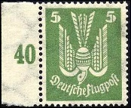

00416 1924. Scott C20, Mi.l 344Y VF NH Sheet margin example. $300.00
n

Germany 1924
14771 1924 (Jun 30) Early airmail cover Berlin to Paris, France with complete set German C20-C26. $150.00
19865 1924 Early Airmail Cover Sent to Switzerland with "Mit Luftpost" label $40.00
24556 1924 (Aug 10) First Flight Card Goerlitz Flight on Official Postal Card $35.00

Germany 1925
01831 1925 (Jul 31) VF blue European sized cover, sent registered airmail from Berlin to Scotland via Bremen. 9 airmails, C12, C13 (x2) C14-16. Neat and attractive cover $100.00
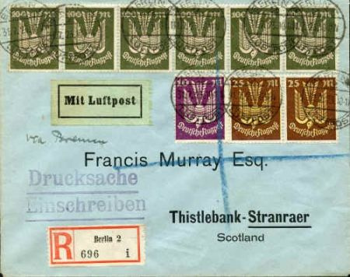
item 01831 Germany 1925 Berlin - Scotland

16277 1925 (Oct 6) Early Airmail Cover from Baden, Franking on front and back. $25.00
19868 1925 (Sep 6) 15pf Printed Airmail Card with "Mit Luftpost" Vignette and additional 50pf airmail $50.00
19869 1925 (Aug 3)15pf Printed Airmail Postal Card from Hamburg $20.00
24558 1925 (Jul 20) 15pf Printed Airmail Card sent from Boeblingen with "Mit Luftpost" Vignette and red box Karlsruhe flight handstamp $35.00
24559 1925 (Jul 30) Goerlitz Flight Card to Deisenhofen. PPC with aerial view of Leipzig $35.00
24560 1925 (Aug 21) Goerlitz Flight Card to Dresden on 15pf Postal Card. "Posthifsstelle Flughafen Goerlitz" Cancel + red box Dresden N.25 hand stamp $35.00
24561 1925 (Apr 24) Mannheim to Hamburg Flight Card with violet box Mannheim flight hand stamp. Part of Mueller #192 flights $40.00
24562 1925 (Jun 9) Berlin Rundflug Flight Card with Special Flight Vignette. Red boxed Munich 2 flight hand stamp $100.00
24565 1925 (May 3) Heilbronn - Wuerburg Flight Cover with red box flight hand stamp. Franked with 3pf and 40pf semi-official airmail, Mi FM17b $40.00
42908 c1925 Advertising Vignette for margarine picturing Zeppelin and Count Zeppelin. $15.00

Germany 1926
01837 1926 (Aug 7) 5pf postal card with added C28. Philately Day cancel sent airmail from Dortmund - Munich. $35.00
01839 1926 (May 22) VF 15pf postal card, like C29, from Dresden to Flensburg. Clean, neat card. . $25.00
01840 1926 First Flight Flensburg-Kiel, Hamburg-Berlin. European sized airmail cover with C27-28. Hamburg and Berlin postmarks on reverse $50.00
14774 1926 (Nov 28) Glider flight card for Glider Meet. $35.00
14786 1926 (Jul 12) Schwerin Airmail on 3pf 10 pf postal stationery. $15.00
14787 1926 (Jul 16) Brunswick to Cologne, Germany airmail flight cover on 3pf + 10pf postal stationery. $30.00
14788 Germany 1926 (Aug 5) Airmail Flight Cover for German Stamp Day on 10pf + 3pf postal stationery with an additional 20pf. $25.00
18114 1926 (Jul 8) Braunschweig Flugafen boxed cancel Flight to Berlin. Not listed as first flight. VF air postal card #p168. $40.00

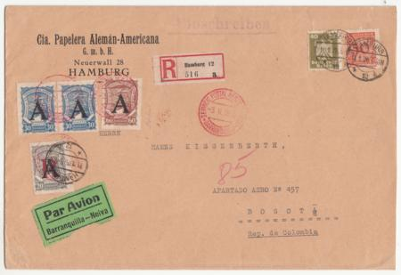
item 20140 Germany 1926 SCADTA Commercial Cover
20140 1926 (Jan 11) Oversized Hamburg - Bogota SCADTA Commercial Cover. Registered cover is 6 1/2" x 9 1/2 " with 327, 335, CLA 27 pair, CLA29 and CFLA2. Properly backstamped and sold with Sismondo certificate $325.00
21381 1926 (Aug 5) Boeblingeer - Karlsruhe Airmail Cover on 3pf + 10pf postal cover. $15.00
24564 1926 (Jun 25) Mannheim - Hamburg Flight on 5pf Postal Card. Weisbaden State Theater corner card. Faint boxed Hamburg flight hand stamp. $35.00
24566 1926 (Jun 5) Mannheim - Konstanz Flight on 15pf Airmail Postal Card. Red boxed flight mark and South Germany flight machine cancel $25.00
24567 1926 (Sep 3) Frankfurt (Main) - Braunschweig Flight on 5pf Postal Card. Red boxed flight hand stamp. $30.00
24568 1926 (Jul 20) Karlsruhe - Munich Flight on 15pf Airmail Postal Card. Red boxed Munich 2 flight cachet. $25.00

Germany 1927-1928
14780 1927 (Mar 21) Berlin -Prague - Vienna flight on 15pf postal card. $20.00
14781 1927 (Apr 19) First Flight Breslau - Prague - Munich on 15pf airmail postal card. $20.00
14782 1927 (Mar 21) Berlin - Prague - Vienna flight on 15pf airmail postal card. Vienna backstamp on address side. $20.00
20141 1927 (Feb 3) Oversized Hamburg - Bogota SCADTA Commercial Cover. Large 6 1/2" x 9 1/2" cover with 335 block with CLA26, CLA29 strip of 3 SCADTA franking. VF except for the neat 1/2" tear at far left. . Properly backstamped, Sismondo certificate $325.00
24569 1927 (Jul 11) Stuttgart - Regensburg Flight Cover with red boxed flight handstamps for Regensburg and Munich and fancy block machine cancel. $25.00
24570 1927 (Jun 15) Hirschberg - Breslau First Flight Cover with red Breslau flight cachet and light green flight label affixed. $30.00
24571 1927 (May 23) Goerlitz - Cottbus First Flight Cover with red boxed Cottbus flight handstamp and red orange first flight label affixed. $40.00
24572 1927 (May 23) Berlin - Cottbus First Flight Cover with red boxed Cottbus flight hand stamp $40.00
24573 1927 (Jun 15) Cottbus - Hirschberg First Flight Cover with both Berlin and Hirschberg handstamps. $35.00
11260 1928 (Oct 7) American Flight Cover and stamped "Returned to Sender". Franked with Scott C37. S.21B $100.00
14779 1928 (May 2) Konstanz First Flight on black & white picture post card of Konstanz. Franking is on photo side. $30.00

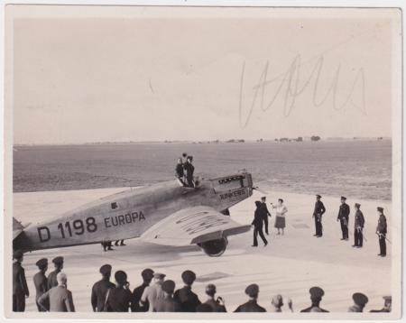
item 21260 Photo Signed by H.Kohl, Aviator
21260 1928 Photograph signed by Hermann Kohl, German pioneer aviator. Photograph is of a crowd around Kohl in his Junkers plane Europa, Kohl was the first to fly non-stop East to West across the Atlantic in his other plane the Bremen, in 1928; signed in pencil in sky on 3 x 4 B&W photo, pencil inscription in German on back $250.00
21330 1928 (Oct 11) Zeppelin American Flight Cover with C37, 4m Zeppelin. S21B €100 $80.00
21382 1928 (Oct 7) Zeppelin American Flight Cover with C37, 4m Zeppelin. Vertical crease on left and minor edge flaws. S21B €100 $70.00
42943 1928 International Air Show in Berlin Vignette, Mint $10.00

Germany1929
09441 1929 (Jul 15) Catapult cover, Bremen. Cover has been opened on two sides, Flight K1a $40.00
09442 1929 (Jul 31) Catapult cover, Bremen. Cover with letter has been opened top and bottom. Flight K2a. $40.00
14793 1929 (May 15) Zeppelin 1st North American Flight cover with C37, 4m zeppelin. Backstamped, New York, NY. S.26A $75.00
16598 1929 (May 15) Zeppelin America Flight Cover to NY with C37, 4m Zeppelin. $85.00
19870 1929 PPC Bremen - New York, Picture depicts the Bremen. Crease through center $15.00
21819 1929 (Mar 24) Orient Flight cover with four airs and three extras. Attractive cover sent to Turkey. Backstamped at Er Ramle, Palestine. A few 1/8'' tears at left could easily be trimmed. Also, a difficult to see tear on right side. S.23 I Aa €175 $110.00
21820 1929 (Apr 22) Zeppelin Mediterranean Flight card. VF card dropped in Seville with Seville backstamp. S24A $50.00

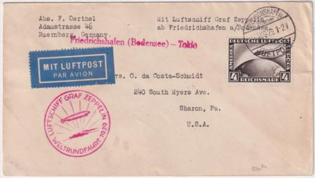
item 21821 Germany RTW Flight Cover to Japan
21821 1929 (Aug 15) First Round the World Flight PPC, Friedrichshafen to Japan and addressed to Sharon PA. S.30Aa $95.00
21822 1929 (Aug 15) First Round the World Flight PPC with C36, Friedrichshafen to Japan. Colorful PPC of boy playing violins to birds. New York backstamp. Some adhesive residues at bottom of card but still very nice. S.29. $75.00
21841 1929 1st Round the World Flight Cover with C37 sent to New Jersey. Backstamped New York. 2c franking added and then forwarded back to Germany by ship. Interesting item. $125.00
24603 1929 (Sep 2) Catapult Flight Cover, Bremen - NY on Roessler airmail cover. Octagon shaped Bremen - New York flight hand stamp. Hab 5a $50.00
24604 1929 (Aug 10) cacheted Catapult Flight Cover, Bremen - NY with red oval Bremen - New York hand stamp. Hab 3a $40.00
24608 1929 First Flight Cover Munich - Klagenfurt with light green flight label.Mi 29-18-02 €40 $35.00
24848 1929 (Jun 21) First Flight Cover Stuttgart - Friedrichshafen with two airmails and Boblingen cancel and flight label. Mo29-19-01 €60 $30.00
27703 1929 (Jul 22) Bremen Catapult cover to USA on PPC of Magdeburg. $35.00
27709 1929 (Oct 7) Netherlands Flight and Silesia Flight Combo Card. Netherlands flight then returned to Friedrichshafen. Then sent on Silesia flight. S.41A and S.43A $1,000.00
35350 1929 (Sep 17) Hamburg Flight on Postal Card with On Board Cancel S.34m €300 $150.00
35351 1929 German Eschweiler Flight Cover with On Board Cancel. S.34f €250. $250.00
35352 1929 German Osbrück Flight Cover with On Board Cancel. Blue envelope with vertical crease. S.34h €500 $125.00
35353 1929 (Sep 17) German Flight Aachen on Photo Card with On Board Cancel. S.34g €350 $175.00

Germany1930
35960 1930 C35-37 VF LH $80.00
35990 1930 C35-37 H, C35 NH but light crease $80.00
30592 1930 C35-37 VF Used $60.00
05236 1930 C35 Used Mi 455 $30.00
05234 1930 C37 NH Toning spot on gum $60.00
05233 1930 C37 LH Perfs separated from margin Mi. 424 $24.00
23233 1930 C38-39 F-VF NH $2,300.00
05240 1930 C38 - C39 F - VF Used $325.00
08006 1930 C38 - C39 Pan Am flight to Lakehurst S.57N $450.00
35433 1930 C38 var. VF “moon Over Airship” variety. Friedrichshafen CDS on piece. €900 $325.00
05239 1930 C39 VF Regummed, appears NH $140.00
11547d Germany / Columbia 1930 Rare Meter SCADTA Cover $275.00
07961d 1930 Circuit flight Copenhagen drop S.68Bd $425.00
09448 1930 Catapult Cover, First Flight of "Europa", K 47, Hab 31. $40.00

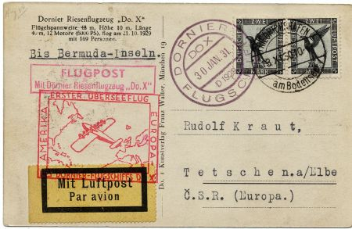
Item 11913 Germany Do-X to Czechoslovakia
11913 1930 (Nov 18) Do-X Flight Card Addressed to Czechoslovakia. Friedrichshafen cancel on official on-board RP PC with boxed "Flugpost ... Do.X" handstamp as sold. Unusual, typed inscription "Bermuda' although flight did not land there. Backstamped "Rio" 22.IV.31, date inverted, cancel error as described in AAMS. Lovely card! $300.00
13154 1930 (May 18) South America Flight card drop mail to Porto Praia, Canary Is. Card with C38with sheet margin plate variety “moon over airship, position 44.” $425.00
14041 1930 (Sep 6) Catapult Cover, Europa - NY, addressed to Buffalo NY. K47b $45.00
14045 1930 (Sep 16) Catapult cover, Bremen - New York, addressed to Buffalo NY. K49d $75.00
14100 1930 (Jul 24) Catapult postal card Bremen - New York K37c $80.00
14802 1930 (May 18) Zeppelin South American Flight cover with C38, 2m zeppelin with overprint. Sent to Seville, Spain. S.57A €500 $200.00
16600 1930 Catapult Cover, Europa - New York, bottom edge of cover torn. $30.00
17206 1930 (Jun 5) Cacheted Catapult Cover Bremen - NY. $50.00
17391 1930 (May 18) C39 VF stamp on Peach Colored Cover with Creasing sent to Brazil. Priced as stamp only. $160.00
17396 1930 C43-C45 Reprint on Completely Fake Cover for North America Flight. $30.00
20120 1930 (Sep 23) East Flight with C38 2m blue "Moon Over Zeppelin" Variety. S.88 Db €60+ €750 Light wrinkling on left edge. $400.00
20131 1930 (Jun 16) Muenster Zeppelin Flight on Lovely PPC. S.65C €60 $70.00
20389 1930 (May 18) South America Pan Am flight to Lakehurst with C38 pair and C39. VF cover slightly reduced at right. Green Lakehurst receiving cancel on reverse. S.57N €650 $395.00
20530 1930 (May 18) Zeppelin South American Flight cover with C38, 2m Zeppelin with overprint. Sent to Seville, Spain. S.57A €500 $200.00
21566 1930-1931 Do-X Flight Cover with C36 & C37. Stamps tied by Nov 13, 1930, cancels. Red rectangle flight cachet tied by on board cancel Jan 30, 1931.Nice long letter enclosed that mentions he is sending it by Do-X but probably never expecting it to take so long! Slight scratch on C36. $350.00
21827 1930 (Apr 22) Flight to Bonn on VF postal card with on board cancel. Addressed to Munich. S54 B €60 $45.00
21828 1930 (Apr 26) Zeppelin Flight to England on VF PPC. Colorful franking, 5pf block of 4 on reverse, not postmarked. S.55A $50.00
21839 1930 (Nov 16) Zeppelin Flight Chemnitz to Friedrichshafen. VF postal card with beautiful franking. S.100Ba $70.00
22297 1930 (Oct 12) Zeppelin Swiss Flight Card to Bern with red Bern Flight cachet on postal card. S.93Aa €40 $50.00
24574 1930 (Aug 3) Zeppelin from Friedrichshafen, Landing in Darmstadt with C32 on US 1c postal card. Darmstadt receiving cancel and red oval Zeppelin handstamp $40.00
24607 1930 (May 1) First Flight Card Baden - Baden to Wiesbaden with red boxed Wiesbaden handstamp and red First Flight vignette. Dewitz certificate attached on reverse. $35.00
24845 1930 (May 18) Zeppelin So. Am. Flight on PPC with C39. Friedrichshafen to Lakehurst with Lakehurst green receiving cancel. PC of aerial view of Berlin. S57N $195.00

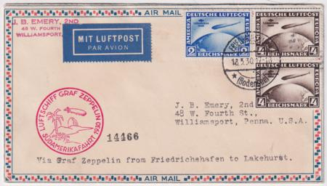
item 24846 Roessler Cover with C38-39
24846 1930 (May 18) Zeppelin S. Am. Flight Cover with C38-C39 on Roessler airmail cover. Red flight cachet and Lakehurst green receiving cancel on the reverse. Scott cv for stamps $900. S.57N $525.00
24849 1930 (Jun 15) Zeppelin Flight to Muenster on Eckener card with C32 tied by on board cancel. Picture side with small faults. S.65B €80 $50.00
24851 1930 (May 1) First Flight Card Wiesbaden - with red flight Handstamp and red First Flight vignette. Dewitz certificate attached on reverse. $25.00
25418 1930 (Nov 13) Do-X Flight on Cover with C36, Sent to New York via Brazil. Rio de Janeiro backstamp. $250.00
25424 1930 (May 18) S. Am. Pan Am flight to Lakehurst with C38 and C39 (x2) on US 2c postal stationery. Green Lakehurst receiving cancel on reverse. S.57N €w675 $400.00
25431 1930 (May 18) South America Pan Am flight cover to Lakehurst with C38 (x2) and C39. Green Lakehurst receiving cancel on reverse. Small repaired tear on top edge. S.57N €675 $250.00
27708 1930 (Mar 19) Catapult Cover, Europa - New York, Maiden Voyage. Corner cover North German Lloyd. $65.00
28315 1930 (Sep 13) Cancelled Vienna Flight. Post card was mailed by the postmaster at Friedrichshafen to a collector who had sent four philatelic envelopes to be posted on the Vienna flight. The postmaster sent this card explaining that the Vienna flight had been cancelled. Since the postmaster was sending this card on official postal patron business, no stamp was necessary. $350.00
28336 Germany / US1930 South American Flight Card Friedrichshafen - Seville. US 1c postal card with 1m Germany airmail added and canceled May 18 in Friedrichshafen. US receiving cancel Jun 2. S.57A $100.00
28562 1930 (Sep 24) Baltic Sea Flight on PC with on board cancel. Stockholm drop, B & W Post Card of Aerial View of Friedrichshafen. S.88Dc $100.00
30589 Germany #C40 1m red, "Polar Fahrt" overprint MINT VF-XF, LH Cat Value $115 $80.00

Germany 1931
35989 1931 C40-42 H F-VF €900 $500.00
05249 1931 C42 F Used, machine cancel $270.00
35097 1931 C42 XF LH €550 $300.00
05246 1931 C42 F-VF H gum soaks at top $150.00
05247 1931 C42 VF Used, better cancel $300.00
07964d 1931 C35, C40 Polar Flight S.119F $500.00
08142d Germany / Luxembourg 1931 Bremen Catapult (K59 LX $1500) $1,000.00
08194d 1931 DO-X on board $500.00
11704 1931 (Jul) Polar Flight Cover with C42, 4mk. On board cancel and better Malyguin cancel, S.119c. €111. ++ $400.00
16602 1931 Matched Set of 2 Zeppelin Polar Flight Cards, Malyguin / Leningrad with 328 and C35. Very unusual without the special flight stamp! $200.00
17406 1931 (May 12) C38 variety with sheet margin: Moon over airship VF stamp on Ostseejahr Flight Cover to Lübeck. Vertical crease at left side. Mi438t €1200 $400.00
20122 1931 (Jul 12) Austria Zeppelin Flight with C38. S.116A 75 + C38. All postal markings on front. $195.00
20148 1931 (May 4) Bremen Catapult Cover to New York. k59D $75.00
21321 1931 (Jul 27) Zeppelin Polar Flight Cover with C42, 4mk. Better Malyguin cancel, S.119 $375.00

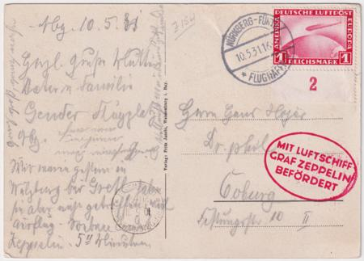
item 21497 Nüremburg Flight Card with C35
21497 1931 (May 10) Zeppelin Nüremburg Flight Card with C35, 1m Zeppelin, to Frankfurt. Rare card! S.107Ca €500= $600. $300.00
22296 1931 (May 3) Zeppelin Pommern Flight Card to Switzerland. Friedrichsahfen backstamp on address side. $60.00
25432 1931 (Oct 17) 3rd South America Zeppelin Flight with C36 (x2). Green flight cachet, Brazil receiving cancel on front S.133Aa €75 $80.00
26799 1931 (Jul 25) Polar Flight to Canal Zone with C41. PPC of Empire State Building sent to Canal Zone. Said to be unique as such. Bottom right corner crease otherwise VF condition. $550.00

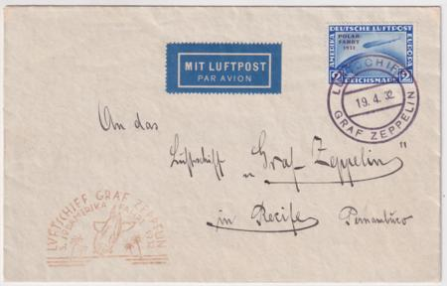
item 25427 3rd S. Am On Board Cancel

Germany 1932
11549 1932 Do-x Red Flight Cachet. this inaugural flight was sent from Germany to US, on board cancel. $500.00
14993 1932 (Oct 4) 4 matching airmail covers to same passenger on ship SS Stuttgart $30.00
17670 1932 (Sep 21) Small Sized Bremen Cover Sent to Buffalo NY. Some creasing at right. $40.00
19606 1932 (Oct 11) 8th S. Am.Flight with C36 on VF Official Airmail Envelope with On Board Cancel.Light horizontal crease along bottom. S.189Ab + C36 €230 $140.00
21322 1932 (Jul31) Danzig Zeppelin Flight Card on Sieger Luposta Card $65.00
24750 1932 (Oct 1) "Dela" Flight Cover to Huntington Park, CA. Also FDC for 5pf Hindenburg $25.00
25427 1932 (Apr 19) 3rd South American Flight cover with C38 tied by On Board Cancel. S.150Ab €100 + C38 cv $300 $225.00
25428 1932 (Sep 15) 6th South America Flight with on board cancels. Green flight cachet and Pernambuco receiving cancel on reverse. S.177Ab €135 $100.00
25429 1932 (Sep 23) 7th South American. Flight Cover with C35 + another airmail on front and additional franking on reverse. S.183Aa €100 $175.00
25433 1932 (Apr 19) 3rd South American Flight cover with C36 tied by On Board Cancel. S.150Ab €100 + $80.00
25434 1932 (Sep 13) 6th S. Am. Flight with on board cancels. Green flight cachet and Rio de Janeiro receiving cancel on reverse. Back flap has a tear. S.177Ab €135 $100.00
25450 1932 (Oct 11) 8th S.Am Flight with C35 + one additional airmail both tied by On Board Cancels. S.189Ab €130. $100.00

Germany 1933
23235 1933 C43-45 NH C43, signed $2,600.00
23236 Germany C43 - 45 NH F-VF+ Schlegel Cert. - Chicago Flight cv $3250 $2,600.00
23234 1933 C43 VF NH $2,150.00
30590 1933 C43-45 F-VF LH $800.00
C43-45 F-VF H, C44 Fine $750.00
21763 1933 C43 VF Mint Hinged cv $800 $625.00
05254 1933 C45 VF H, Mi 498, 4m single $60.00
22054 1933 C43-45 VF Used $500.00
07976d 1933 C44 on Chicago flight to US S.238Bca $375.00
13072 1933 (Oct 14) Chicago Flight cards, C43-45 complete set on 3 cards with extra stamps. Some edge faults on 2 cards. Scott as used $1375. Sieger €1975 $650.00
16610 1933 Zeppelin So. America Flight Cover Front with C43. Cv for C43 as used single $400.00 $200.00
16619 1933 (Nov 4) Rocket Flown Card, Hasselfeld Night Flight with 3 different rocket vignettes, and Signed Zenker. Only 38 cards & covers remained after the explosion. $300.00
19607 1933 (Jun 3) VF 2nd South American Flight with C36 and On Board Cancel. S.214Ab + C36 = €190 $125.00

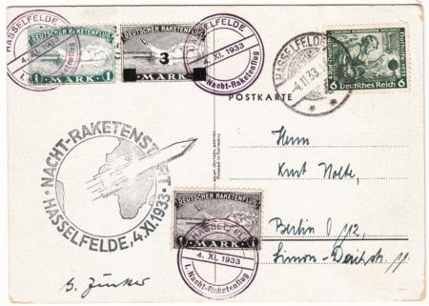
item 16619 Germany 1933 Signed Rocket Card
25136 1933 (Oct 10.) C43 and C44 on registered Chicago Flight Cover from Hamburg, sent to Astoria NY. Chicago and Long Island backstamps S.238Bca €375 $275.00
25494 1933 (May 6) 1st South American Flight Cover, Friedrichshafen to Recife. Blue flight cachet and colorful twelve stamp franking. S.202Aa €100 $80.00
28317 1933 (May 6) 1st South American Flight Cover on Zeppelin Postal Stationery. Condor ad on the reverse. Light vertical crease down center. S.202Aa $100.00
28318 1933 (Aug 4) Zeppelin 4th S. Am. Flight Cover sent from Friedrichshafen. $150.00
28319 1933 (Aug 18) Zeppelin 5th S. Am. Flight Cover sent from Friedrichshafen. Small sized cover with a very light vertical crease down the center. S.226A $150.00
36126 1933 Zeppelin Flight Cover, Dresden Drop Off and On Board Cancel. Dresden backstamp. S.201Aa $75.00

Germany 1934
08133d 1934 Europa Catapult -Guatemala $350.00
24751 1934 (May 26) Zeppelin 1st South American Flight on Sieger Card with Stuttgart cancel. Sent to Pernambuco Brazil with red flight cachet. Believed to be only 54 cards carried. S.247Ba €75 $100.00
25769 1934 (Jan 29) Rocket Post cover with 3m imperf rocket mail vignette in silver and green. XF cover is franked with 399a and signed Zenker and backstamped Berlin Jan 30. $250.00
25770 1934 Rocket Post cover with Two 1/2 m imperf Rocket Mail Vignettes, one brown/orange and the other brown/black. XF cover franked with B49, B53 and B54 and backstamped Berlin Jan 30 $225.00
25797 1934 (Jan 29) Rocket Post cover with 1/2 m perfed pair Rocket Mail Vignettes in brown/orange. XF cover franked with B54.EZ6C1a $180.00
27937 Germany 1934 (Mar 2) Commercial Catapult Cover To Rio with unusual franking. $50.00
27938 1934 (Sep) Commercial Catapult Cover to Porto Alegre with C55. $175.00
27939 1934 (Oct 5) Commercial Catapult Cover to Rio. $60.00
27940 1934 (Nov 2) Commercial Catapult Cover to Rio from A. Hartrodt cover, transportation company $100.00
28320 1934 (Jul 19) VF Zeppelin 4th South American Flight Cover sent from Friedrichshafen. S.260Aa $75.00

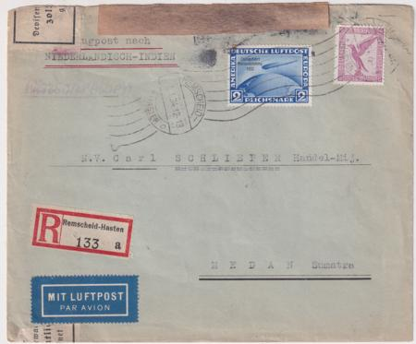
item 28322 Flight Cover to the Dutch Indies
28322 1934 (Jan 7) C44 2m Chicago Flight ovpt. Stamp on Registered cover to the Dutch Indies.. Opened by customs. $375.00
28323 1934 (Aug 3) Zeppelin 5th South American Flight Cover on airmail cover to Rio de Janeiro. S.265Aa $60.00
28324 1934 (Aug 18) Zeppelin 6th South American Flight Cover on airmail cover to Rio de Janeiro. S.268A $85.00

Germany 1935
07953d 1935 C35 on 14th SO. Am. flight. Stamped "sample" in German S.324B $450.00
07962d 1935 9th South American flight stamped "Sample" in German. S.313B $475.00
01887 1935 Catapult flight cover from SS Bremen and Europa sent to NY. Rare combination! Expertly repaired at right. $250.00
08137d 1935 Double Catapult, Europa & Bremen on Bremen Envelope $575.00
16422 1935 (Dec 10) European sized Gray Airmail cover from Munich with B88 single franking. Large yellow and black vignette on reverse for Kallmunz.. Vertical crease down center of cover. $50.00
16767 1935 (Sep 4) Catapult Cover, Europa - NY via Koln/Cherbourg with letter. 3 stamp train franking. K239c $100.00
17122 1935 VF Baggage Label for Do-X $125.00
27941 1935 (Feb 1) Commercial Catapult Flight Cover, Europa - South America. Airmail Yale & Towne Mfg. Co. cover addressed to Porto Alegre with nice Flight cachet and metered franking. $150.00
21528 1935 Catapult Cover Europa – Southampton $50.00
27942 1935 (Mar 29) Commercial Catapult Flight Cover to Paraguay $65.00
27943 1935 (Jul 30) Commercial Catapult Flight Cover to Rio with Perfin $85.00
27944 1935 (Oct 29) Commercial Catapult Flight Cover to Rio $25.00
27945 1935 (Oct 29) Commercial Catapult Flight Cover to Rio. Airmail A. Hartrodt, transportation company, cover with two perfins $85.00
28325 1935 (Apr 5) 1st South American Flight Cover. S.290Aa $100.00
28326 1935 (Apr 18) 2nd South American Flight Cover. Small flight cover sent to Rio. S.293Aa $75.00
28327 1935 (May) 4th South American Flight Cover. S.299Ba $100.00
28328 1935 Airmail Cover from Germany to Bogota, Colombia. $100.00
28503 1935 (Apr) ) 1st South American Flight Cover. S.290Aa $100.00

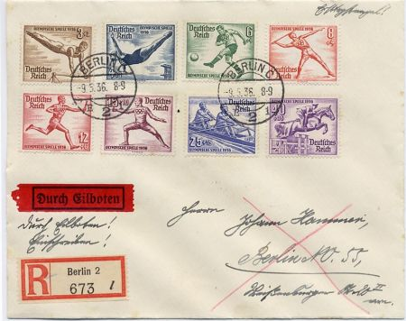
item 03767 Germany B82-89 FDC

Germany 1936
01895 1936 (Jan 22) 4th South Atlantic flight. C50, C52, C55 on double rate cover to Brazil.. $100.00
01896 1936 (Jun 12) Catapult cover, airmail flight Koln - NDL liner Europa at Cherbourg. C49, 2x 475 on cover to NY, addressed to H.Gudula Einstein. Rough opening at top, horiz. crease through center. $50.00
03767 1936 (May 9) Olympic set, B82-89 FDC. VF Cover sent registered from Berlin, "Durch Eilboten" label in red and black $1,600.00
16650 Germany 1936 (Oct 5) Zeppelin No. Am. Flight Card sent registered to Switzerland with C55. S.441B $100.00
17104 1936 (Aug 21) Catapult Flight, Europa, with connecting flight cachet in brown. Cover then sent commercially to San Francisco CA. $50.00
17464 1936 (Aug 1) Olympic Flight on VF card Sieger 427B $50.00
17672 1936 (May 8) Hindenburg 1st North America cover with C58 tied by on board cancel, to New York $50.00
17714 1936 (Aug 1) Olympic Flight Cover with B82-89. S.427Bb €225 $135.00
17719 1936 (May 5) 1st North America large, registered flight cover with 469 (airplane on stamp) block of 4. Addressed to Washington DC. $75.00
19635 1936 (Aug 5) 6th North American Flight of Hindenburg with C57-C58 and B90 S/S on registered cover. S.428C $120.00
19872 1936 (Aug 5) Hindenburg 6th NAm Flight Cover sent registered to NY with complete Olympic set, B82-B89. $250.00
19873 1936 (Aug 1) Hindenburg Olympic Flight on Postal Card. All postal markings on address side $50.00
20151 1936 (Apr 2) Registered Airmail Card with C57-C58. Nice pre-Zeppelin flight usage. $25.00
21318 1936 (Aug4) 6th North America Flight on Hotel Commercial Cover. Vertical crease in center. S.428 $35.00
21494 1936 (Aug 1) Hindenburg Olympic cover with C57. S.427 $45.00
24613 1936 (Dec 16) Catapult Flight Card, Europa, Signed by Helms. Cologne – Cherbourg $30.00
25498 1936 (Aug 30) Graf Zeppelin Flight Cover to Leipzig. Addressed to Hotel Astoria with 4 stamp George Frideric Handel franking. S.365B $50.00
25646 1936 (Aug 1) Hindenburg Olympic Flight Cover with C54. Rhein-Main cancel, Berlin backstamp S.427B €45 $40.00
25647 1936 (Aug 1) Zeppelin Olympic Flight Card, Rhein-Main Flight Cancel. Olympic flight cachet. S.427B €45 $40.00
27705 1936 (Oct 5) 10th Hindenburg North America Flight Card with stamps tied by Bordpost cancel. New York backstamp. S.441A $75.00
27706 1936 (Aug 29) Catapult Flight, Europa, Round Trip, Bremen- NY. Horizontal crease at bottom and a few edge flaws. K87X1 $200.00
27712 1936 (May) 2nd North American Hindenburg Flight Cover addressed to New York. Commercial use, vertical crease down center. S,410B €110 $75.00
28329 1936 (Mar 11) Airmail Cover from Germany to Paraguay. $40.00

Germany1937-1939
01903 1937 Airmail postal card, Berlin National Ausstellung cancel. $15.00
01904 1937 (Oct 22) Registered cover from Esslingen sent airmail to Denmark. 53, 80pf air single franking. Backstamped Odder and Copenhagen. Paper hinge remnants on back. $35.00
17417 1937 (Aug 28) Bremen Cover "Uber Coln" with Connecting Flight Cachet on Reverse. One stamp torn prior to affixing on cover. $40.00
25032 1937 (May 7) Europa Catapult Cover Halle / Liepzig Flughafen Cancel. Addressed to New York. Signed Helms on the reverse $35.00
27946 1937 (May 11) Commercial Catapult Cover to Argentina. Continental manufacturing company cover sent to Buenos Aires $100.00
05257 Germany 1938 C59 - C60 VF NH $35.00
10718 Germany 1938 (Dec 1) VF Sudetenland flight cover with Scott C55, S.456. $45.00
15126 Germany 1938 (Jul 8) Cover with C59-60, Count Zeppelin and airship. Cover is missing back flap. $20.00
20175 1938 (Sep) Catapult Flight To New York with C59 (x 2) $50.00
24753 1938 (Nov 18) Catapult Flight To New York and FDC for B123-B131 (Mi €500) Registered cover to New York with backstamp. Light wrinkling at top and right of cover not affecting stamps. $250.00

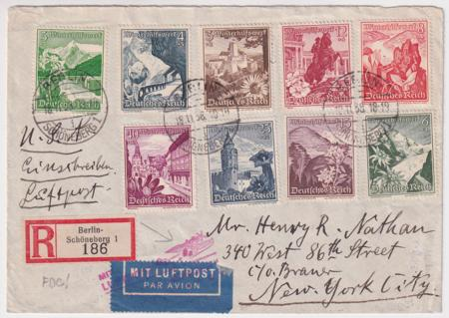
item 24753 Germany 1938 Catapult, B123-31 FDC
15054 Germany 1939 Zeppelin Flight to Bielefeld $40.00
20135 1939 (Jul 16) Zeppelin Flight Card to Goerlitz. S.458 $40.00
24764 1939 (Aug 22) Catapult Cover Bremen with Partial Booklet Pane of Pres. von Hindenburg. Scarce franking. Right edge small tear and wrinkling. $35.00
27707 1939 (Jan 26) Catapult Cover Bremen to New York. K300A $75.00

Germany 1940’s-1970’s
27864 1940 (Oct 29) Airmail Cover to NY via Lati, Italian Airlines. Lati airline only had the transatlantic service from 1939-1941. $100.00
01924 1949 Berlin Aerogram LF 26III. VF commercially used to NY, carefully and neatly opened. $60.00
01922 1955 (Jul 29) Gray green European sized cover sent airmail from Achern to Basel, Switzerland. Some light toning at top edge of cover. $12.50
01925 1955 (Jul 12) Blue airmail cover with Lufthansa airmail set, C61 - C64, addressed to Zurich, Switzerland. $30.00
17364 1978 B550 NH VF Sheet of 50 Zeppelin, LZ1 from 1900. cv$35.00 $28.00

Great Britain
08042 1845 (Sept 16) Advertising flyer for Balloon night ascent by H. Green from Cremorne Gardens “…Moonlight … Fun and Fireworks!” Wonderful illustration of the balloon in flight with the cheering crowd below. Measures 5” x 10” and is in beautiful condition! $650.00
36530 circa1910s Mint Bleriot Monoplane Photo PC with insert of Pilot William McArdle, co-founder of the New Forest Aviation School. $20.00
36128 1915 "Zeppelin Triumph" Anti German Propaganda Label. $5.00
08097d 1917 (October 11) to British Officer in Cairo - damaged through enemy action. $750.00
16432 1920 (Sep 18) First Flight Cover from London - Copenhagen, Denmark. This Philatelic Institute cacheted cover has a few light wrinkles. $360.00
08147d 1928 "Ile De France" Catapult with 2/6 Seahorse. Registered, Rare! $600.00
28330 1939 (Feb 14) Airmail Cover to Buenos Aires, Argentina. Backstamped Feb 19. $100.00

Greece
42944 1926 Early Airmail Set of 3, NH. Helos 1-3, unlisted in Scott. Made for the Italy - Greece - Turkey route. $30.00
12039 1933 C5 - C7 LH cv $118 $65.00
05260 1933 C7 VF Used 120d single $42.00
05259 1933 C6 VF Used 100d single $42.00
05260 1933 C7 VF Used 120d single $42.00

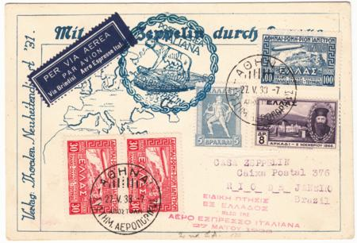
item 16433 Greece 1933 Italy Flight
16433 1933 (May 27) Registered Italy Flight Zeppelin Card Sent to Rio. Cacheted postal card has 2x C5, 1x C6 and 2 additional stamps. In pristine condition!
Mi305Gc S.210x variety $750.00
39139 1933 Complete set of zeppelins, C5-C7 on Zeppelin Aero Express Italy Postal Card tied by last day cancels. Un-flown but unusual. $85.00
01930 1940 (Aug) Small registered cover sent airmail to Royse, Tx, US. Registry label on reverse as well as New York and Texas backstamps $75.00
17681 1940 C38-47 VF Mint LH Appears NH but slight marks from crystal mounts, as LH cv $325.85 $220.00

Guatemala
21227 1930 (Jun 29) Rare "Memorandum Postal' Preprinted Cover with C7 airplane style overlapping Imprinted Stamps. "Guatemala produces the best coffee in the world". Mt Agua Volcano, Coffee flight to Quezaltenango. Inauguration of airmail flights in Guatemala. $150.00
08105d 1936 Hindenburg S.409P $875.00

Hungary
05262 1931 C24 - C25 F-VF NH $120.00
08000d 1931 Polar flight to Switzerland $650.00
07978d 1933 Chicago flight to Brazil $475.00
08118d 1936 8th North American Flight $450.0

Iceland
07959d 1931 Iceland flight, S.114D Variety $500.00
07960d 1931 Iceland flight. Registered Post Card S.114 Unlisted variety. $450.00

India
17333 1935 (Feb 27) Rocket Mail Cover from Dhakuria, Signed by S.H. Smith. Rocket with 130 covers cleared a number of trees and exploded but the mail was salvaged. $150.00

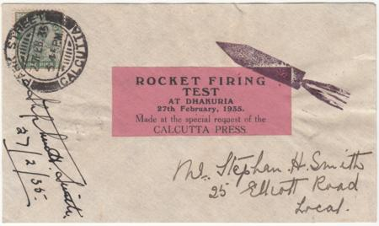
item 17333 India Rocket Mail, Signed by Smith
17334 1935 (Mar 23) Royal Silver Jubilee Rocket Flight from Diamond Harbour signed by Stephen H. Smith. The flight carried 200 covers from ship in Diamond Harbour to shore. $250.00
27711 1936 Scipio Mirabella Bay, Crete Air Crash Cover. The Imperial Airways flying boat "Scipio" crashed at Mirabella Bay, Crete en route from Alexandria to London. $150.00
36623 1947 (July 1) First Flight Calcutta – New York $20.00

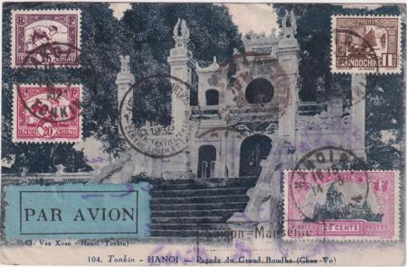
item 21239 Indochina 1933 Marseille Flight

Indochina
21239 1933 (Mar. 28), Air Orient Indochina-Marseille flight, recovered at Crotone (Italy), pretty picture post card addressed to Belgium with black boxed "Saigon-Marseille" and straight-line "COURRIER ACCIDENTȢ handstamps on reverse, Very Fine. Nierinck 330328; SFr 1,500 ($1,550). Estimate $300 - 400 The Lioré Olivier 242 seaplane broke its moorings at Crotone in Calabria during a storm and was stranded on the beach, soaking the mail. Only after the plane was refloated did Italian authorities dry out the mail, which was delivered to Marseille by the relief plane F-AJLJ. $375.00

Iraq
08021d Iraq 1933 5th So. Am. Flight $1,500.00

Ireland
16631 1932 (Apr 26) 4th South America Zeppelin Flight on VF Cover. Apparently only 8 flown so undervalued. S.157 $500.00
16632 1932 (Apr 14) 3rd South America Zeppelin Flight Through Berlin on VF Cover. Apparently only 8 flown so undervalued. S.150B $500.00
20388 1932 (Sep 8) 6th South America Zeppelin Flight on VF Cover sent through Berlin. Beautiful Zeppelin over lighthouse green cachet. 18 flown. S.177 €350 $325.00
16629 1933 (Apr 5) 1st South America Zeppelin Flight Through Berlin on VF Registered Cover. S.202 $425.00
16630 1933 (Aug 16) 5th South America Zeppelin Flight through Berlin. VF cover with "Via Condor Zeppelin" 4-line backstamp. S.226 $400.00

Time Payments are possible!
Let us know your interest, Time payments can be suited to suit your budgetary needs

Israel
18085 1956 (Jun 25) Registered cover with C1-6 tab set on Lydda First Day and First Flight to NY. Cacheted, registered and properly backstamped in NY Guaranteed genuine! Bale $4500. $2,000.00

Italy and Colonies
39013 1928 Polar Expedition of Airships Vignette Set of 4, red, brown, green and blue. $150.00
39012 1932 (Jun 11 ) Airmail cover to Milan welcoming Amelia Earhart. Facsimile Mussolini signature in lower left. $100.00
05268 1933 C42 - C47 VF NH $220.00
05271 1933 C42 - C47 VF LH $90.00
20271 1934 5 Lire Rocket Mail label tied on piece $40.00

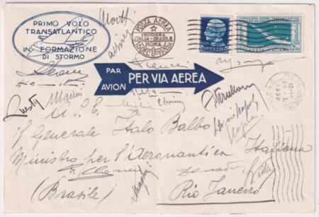
item 25504 Italy 1930 Balbo Squadron- Pilot Signatures
25504 1930 (Jan 22) Balbo Transatlantic Squadron Rome - Rio de Janeiro with C27, special transatlantic squadron stamp. Signed by 18 pilots including Balbo! Faint vertical crease down the center $750.00
25573 1930 (Jan 22) Balbo Transatlantic Squadron Rome - Rio de Janeiro with C27, special transatlantic squadron stamp. Signed by 18 pilots including Balbo! $950.00
24850 1933 Excellent Flight Cover Forgeries with C48-C49, Rome - New York covers to Iceland. Genuine Stamps on counterfeit covers, signed. $300.00
17127 1934 (Jan 25) Pan Am Direct Flight to Argentina with C34. VF small sized cover with proper Backstamps. Scott cv $600.00! $300.00
25608 1934 (Oct 31) Rocket Mail Cover with Two Rocket Mail Vignettes, 7.70 green/silver and 5L red/green, both triangular. Sent to Germany $175.00
16622 Italian Colonies 1934 (Feb 23) Registered Oversized Cover Tripoli - Rome with 384, C20-26 (set without last value) Sassone cv France3 Pre cancels Yv 69//77 Used VF750 $225.00
05315 Italy Cyrenaica 1933 C12 - C17 VF H $45.00
04716 Italy Trieste Zone A C20 (Sa 20e) VF NH. Ovpt shifted sharply to lower right $140.00
11530d Tripolitania 1933 Express Balbo Flight to Switzerland $2,750.00

Jamaica
36615 1930 FAM-5 First Flight - Collection of 9 Different , Miami , Canal Zone and Foreign Destinations $75.00
13074 1936 (May 2) North America Flight cover. Lascelles, Jamaica return flight with cachet. Neat vertical fold down center. S. 409S 1500, Mi 1500 $875.00

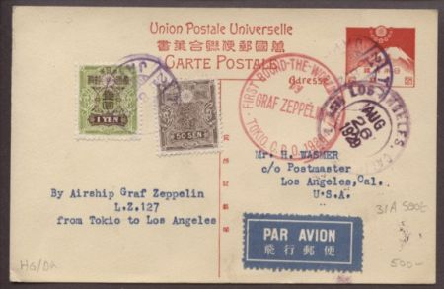
item 07966 Japan 1929 Tokyo to Los Angeles

Japan
07966 1929 Return Flight Tokyo to Los Angeles $500.00
21840 1929 Unflown Zeppelin postal card with red Japanese Zeppelin cachet. $75.00
17360 Japan / Philippines 1954 (Jan 14) Tokyo to London Crash in Rome on Philippine Air Lines. All three crash markings are on the face and they are VF. Nierninck 540114a, f, i (in blue) Sfr. 560. $250.00

Latvia
05281 1932 CB11a - CB13a VF LH High values of imperf set $33.00
11559d 1933 7th South America Flight. S.232B $925.00

Liechtenstein
22591 / Switzerland 1926 First Swiss African Flight to Italy. Liechtenstein Schaan postmark Nov. 10, 1926. Switzerland C3 and C6 added, sent from Zurich to Napoli Nov. 28, 1926 then forwarded to Milan Dec 8.SLH Sfr 3,000. = $3250. $1,650.00
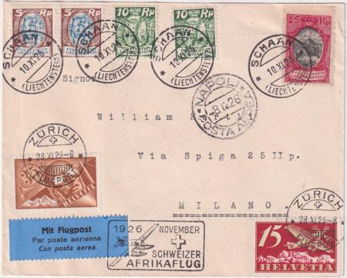
item 22591 1926 1st Swiss African Flight to Italy

26731 / Switzerland 1926 (May 14) La Chaux de Fonds - Basel Flight Cover. VF registered cover with Liechtenstein B10 (somewhat oxidized) and Switzerland C7. LBK 5a Sfr 1600. SLH RF26.7cL Sfr 2500. $650.00
22589 / Switzerland 1928 (Apr 23) First Flight Geneva-Zurich-Munich-Vienna. Registered cover with Liechtenstein B7-10 postmarked April 23 then to Switzerland, C3 added and postmarked Apr 24. Backstamped Geneva. SLH Sfr. 1500 = $1625.RF28.ldL Very rare! $750.00
19620 1930 (Sep 4) Bremen Catapult Flight with 4 VF stamps on F-VF Cover to Bahamas. LBK 8 Sfr 1300 $775.00
20314 1930 (Oct 16) Catapult Cover, Europa - New York. XF small sized cover with C3 x2, C4 and C5 (cv $220.) LBK 13 Sfr 1100. $600.00
25421 1930 (Aug 4) Zeppelin Flight Cover to Darmstadt. Friedrichshafen to Darmstadt, addressed to New York with NY backstamp. S.76 €350 $250.00
20310 1931 (May 2) Catapult Cover, Bremen - New York with Scott 97, 99, 101, 103. LBK # 30 Sfr 1100. $550.00
22588 1931 (Jun 10) XF Cover Intended for Vaduz - Lausanne Zeppelin Flight with C2, C4 and C5 = 1fr. Reverse is stamped "Nur vollstaendig mit Zeppelin Marken frankierte Post zum Zeppelinflug zugslassen" Only fully franked with Zeppelin stamps are permitted on Zeppelin flight. Very rare. LBK Sfr 1200 = $1300 $675.00
25645 1931 First South American Flight, pDrop in Cape Verde then sent to New York. Green flight cachet, C2, C3, 107 (x 2). (S.124 125 +) $200.00
26032 1931 (Jun 10) Zeppelin Flight Vaduz-Lausanne. C8, 2fr zeppelin on XF specially printed cover with "Mit Zeppelin" imprint. LBK 21 Sfr 500. (SLH/47A Sfr 700) Scarce. S.110B €425 $300.00
26230 1931 (Jun 10) C7 Pair on VF Cover to Germany. Vaduz - Lausanne Zeppelin Flight. All postal marking on front. LBK 2C Sfr.600 S.110A $275.00
26231 1931 (Jun 10) Vaduz - Lausanne Zeppelin Flight. Unusual card franked with C2, C4 & C7Flown then sent to Danzig. The C2 and C4 tied normally by Vaduz CDS and the C7 tied only by the red flight cachet. Much scarcer. $250.00
26733 1931 (Jun 10) Specially Printed Postal Museum PPC with C7, 1fr Zeppelin. PPC in XF condition depicts airship in flight and is printed with "mit Zeppelin" on address side. LBK #2i Sfr 350 $295.00
28563 1931 (Jun 10) C7 on VF Vaduz Flight Card to Germany. All postal markings on address side. S.110A $150.00

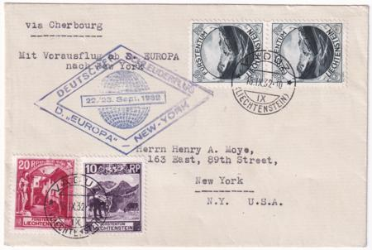
item 20317 Liechtenstein 1932 Catapult
20317 1932 (Sep 15) Catapult Cover Europa - New York. XF cover to NY, New York with Scott 96, 97 and 98 (x2) cv $104. LBK #49, only nine flown. Sfr 1500. $850.00
20312 1933 (Apr 24) Zeppelin German Flight Card with C3 and C6. C6 with plate variety damaged UR corner Sfr 280 as used, Sfr 400 on cover. VF card sent to Zurich. Rare! S.201Aa LBK 78 $375.00
20318 1933 (Sep 6) Catapult Card Bremen - New York. XF postal card with Scott C4 and C5 cv $130. All postal markings on front. LBK 66 Sfr. 900. $500.00
26734 1933 (May 17) Columbus Catapult Cover to New York. VF cover with #98 and C1 . Light stain in upper left. LBK 46 Sfr 2000. $650.00
03051 1934 (May 17) Catapult cover "Bremen" to New York. Addressed to Schenectady, NY. Small tear at bottom edge. K179LN cv $1000. Hab.153 $400.00
20313 1934 (Apr 30) Catapult Cover, Bremen - New York. VF registered cover with C1-3, C6 (cv 150). LBK69 Sfr 1200. Only 13 flown $650.00
13133 1936 (May 9) Hindenburg 1st North American Flight Cover with C12 and C16. Triesenberg cancel addressed to Montclair, NJ $100.00
13136 1936 (May 9) Hindenburg 1st North American Flight cover with C15-16. Sent to zeppelin office in New York $150.00
16651 Liechtenstein 1936 (May 4) C15-C16 on 1st No. Am. Flight to NY on XF+ Cover sent registered. $110.00
22595 1936 (Apr 17) Vaduz registered PPC then on Le Locle - Biel Flight within Switzerland. Rare with only a few flown. Black & white PPC of Do-X. SLH RF36.2aL Sfr 1600 = $1725. $800.00
03484 `1957 (Feb 8) Mittelholzer Memorial Flight Cover to Cape Town, South Africa on Swissair. Only 20 flown, very rare! $400.00

Luxembourg
11718 Luxembourg / Germany 1936 (Oct 1) 10th North America Flight postal card with Germany C57 added. Sent to New York. (S.441) €300. $275.00
11753 Luxembourg / Germany 1936 (Sep 22) 9th North American Flight Card unlisted in Sieger. $250.00

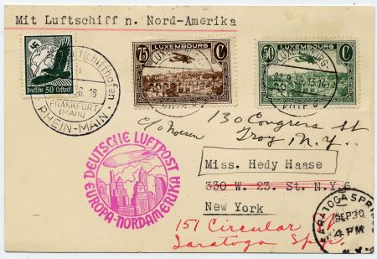
Item 11753 1936 9th N. Am. Flight Card
11754 Luxembourg/ Germany1936 (Oct 5) 10th S. Am. Flight Card (S.441) €300 $275.00
11914 Luxembourg / Germany 1936 9th North America Flight Card. Unlisted in Sieger or Michel. Card forwarded. $250.00
20136 Luxembourg / Germany 1936 (May) Hindenburg 1st North America Flight with mixed franking. Sent registered to Syracuse, NY S.406 $200.00
28258 Luxembourg / Germany 1936 (Oct 1) 10th North America Flight postal sent to New York. Luxembourg C3 pmk Oct 1 and Germany C52 pmk Oct 5(S.441B) $275.00
28259 Luxembourg / Germany 1936 (Sep 22) 9th North America Flight Cover sent to NY. Luxembourg C3 pmk Spe 22 and Germany C47 and C51 pmk Sep 26. S.439B $275.00
28260 Luxembourg / Germany 1937 (Apr 10) South Atlantic Catapult Cover sent registered to Argentina. Germany franking cancelled Apr 12 added on reverse. Buenos Aires backstamp. $400.00
08196d 1939 Registered South American Catapult to Canary Islands $375.00
21552 / Germany 1939 VF Censored Registered Airmail Cover to Canary Island. $90.00

Malaysia
21238 Penang, 1928 (Dec. 7), Penang - Amsterdam Flight, registered cover posted in Muar Dec. 3, 1928, and addressed to Birmingham, England; blue crossed Registry marking and Muar registered handstamp with "P. & T. Mail 25/By Air Mail" label and manuscript "Marseilles-London" on front; reverse reveals indistinct Joh[?] 4 DE cds., Penang 7 DE 28 double-circle cds., red "registered/London, E.C/30 DE 28/4" receiver and Sutton Coldfield/31 DE/28/Birmingham receiver - along with a wax seal, Very Fine, Boesman Postvluchten #22s. $175.00

Marshall Islands Imperfs
Ask for our price list of these previously un-known Press Sheet Archives of Marshall Islands from 1989-2006! Included is almost every issue from this period. Marshall Islands Press Sheets are similar to U.S. Press Sheets – the original format in which the stamps were printed. Unlike U.S., Marshall Islands press sheets were never sold, only cut down and sold as normal sheets through the Post Office & Agency.

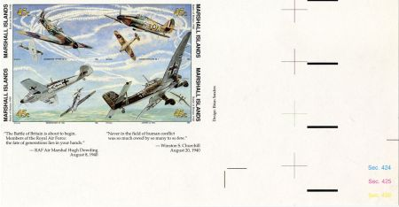
item 21238 Marshall Is 216-64 Imperf Block
21238 261 - 264 Imperf, Battle of Britain Block of 4 $312.50
06802 779 Imperf US / Russia Manned Space Flight $90.00
09014 391 - 394 Imperf Block of 4, Space Shuttle flights $75.00
09063 839 imperf miniature sheet of 50, World's Greatest Aircrafts, Wright Flyer, Bleriot, Curtiss, Concorde. $400.00
09068 846 imperf block of 4 from the press sheet, World War II, Battle of the Bulge, amor, aviation. $200.00
09090 877 imperf from press sheet, first spaceflight, Yuri Gagarin, Russia. $25.00
09091 877 imperf block of 4 from the press sheet, first spaceflight, Yuri Gagarin, Russia. $25.00

Mexico
08123d 1936 2nd N. Am.an Flight S.411D $750.00
08125d 1936 2nd N. Am. Flight S.411D $750.00
08126d 1936 2nd N. Am. Flight S.411D, stains. $450.00
17365 1939 (May 23) C93A VF stamp on Commercial cover, Sarabia NYWF First Flight. A somewhat tired looking cover, priced as a used stamp. $250.00
14860 1950 Airmail cover with C193 to California signed by pilot Juan Pablo Aldasoro Suarez, pioneer aviator. $55.00

Monaco
08188 Monaco / Chicago 1933 Flight to Brazil S.238Aa $1,250.00
08189 Monaco / Chicago 1933 Flight to Brazil S.238Aa $800.00
08100 Monaco / France 1956 Crash N. 560127a $450.00
08181 1932 5th South American Flight sent to Brazil S.171Aa $875.00

Netherlands
25430 1930 (May 6) S. Am. Flight Cover to NY with C4-5, C6 (x2). Reverse has a beautiful Fiat Auto label tied by green Lakehurst receiving cancel. (S.57) €250 $175.00
14043 1932 (May 5) Catapult B & W picture post card of Rotterdam with windmill. Netherlands airmail on picture side. K101 NE $275.00
14046 1932 (May 19) Catapult cover Europa - New York, addressed to Albany, NY. K103 NE $350.00
14047 1932 (Sep 1) Legal sized Catapult cover, Europa - New York, only 12 flown! Some wrinkles on left of cover. K127 $275.00
14076 1932 (Jun) Catapult on B&W picture post card of aerial view of Rotterdam, Bremen - New York. K109 NE $325.00
14078 1932 (Jul 23) Catapult cover, Europa - New York. WIPA 1933 label on reverse. K111 NE $350.00
14084 1932 (May 4) Catapult B&W picture post card of the Fokker VII in flight, Europa - New York. K99 NE $450.00
14090 1932 (May 30) Catapult B&W picture post card of aerial view of Rotterdam. Bremen - New York K105 NE $325.00
14104 1932 (Sep 23) Catapult Government 7 1/2g postal card with Old Water Warehouse sent Bremen - New York. K133 NE $350.00
39140 Netherlands/Germany/Colombia/Brazil 1932 (Mar16) 1st South American Zeppelin Flight Cover. Registered cover with 3 stamp Netherlands franking tied by Mar 16 cancels, Germany C35 Zeppelin + definitive tied by On Board Graf Zeppelin cancel and single stamp franking from both Colombia and Brazil. S.138 $1,100.00
14075 1933 (May 5) Catapult, color PPC of Rotterdam with windmill. Europa - New York. Franking on picture side. K137 NE $375.00
14074 1934 (Jun 4) Catapult cover Bremen - New York. London 1934 Air Post Exhibition label on reverse. K183 NE $325.00
14106 1934 (May 7) B&W picture post card of Rotterdam Europa - New York. K177 NE $350.00
21551 1934 VF Airmail Cover from Rotterdam to Curacao with backstamp. Small sized cover. $25.00
26732 1936 (Sep 15) 8th North America Hindenburg Flight Cover. Smaller sized VF cover sent to New York. S.437 €100 $80.00

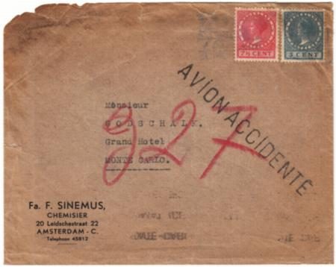
item 16551 Netherlands / Belgium Crash to Monaco
16551 Netherlands / Belgium 1937 Early Airmail Flight Crash to Monaco, stamped "Avion Accidenté" $750.00
15046 1942 and 1943 Dutch Legion Mi BL1 on cover and Mi. BL 2 on cover. $175.00
08119 Netherlands Indies1936 7th North American Flight to Austria. S430B $525.00
08117 Netherlands Indies 1936 7th h North American Flight S430B $750.00

New Caledonia
05058 1933 #182-207 Mint blocks of 4 with F-VF appearance but some with thins or gum disturbances from being stuck down. A few perf separations. Overprint of plane Paris-Noumea flight. Scott retail $576.00 $80.00

Newfoundland
11909 1921 (Nov 24) Early Airmail Cover with C3. Stamp is VF, the cover has a vertical fold away from the stamp $125.00
17153 1921 (Nov 13) C3b, ovpt. with period, VF on F-VF airmail cover sent to Eugene Klein (Pres. APS) Halifax backstamp cv $225. $150.00
25800 1921 (Nov 26) VF Airmail Cover with C3, Halifax overprint without period. St. John's NFLD cancel. $160.00

New Guinea
01963 1939 (Mar 13) C46-48, C51-54 on 4 airmail covers, stamped "First Day of Issue" 1 cover registered. T.N.G - Austria, addressed to Garden City, NY $225.00

New Zealand
41400 1937 (Dec28) 1st Flight Cover from New Zealand to American Samoa Signed by Captain Edwin Musick. $100.00

Norway
28261 1936 (Sep 21) 9th N. Am. flight to NY, NY and then forwarded. S.439B $250.00

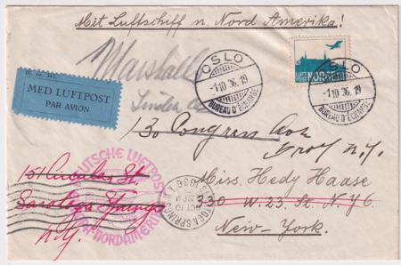
Item 28262 Norway 1936 10th NAm. Flight

28262 1936 (Oct 1) 10th North American flight to New York, NY and then forwarded. S.441B $250.00

Panama
17374 1928 256-257 Lindbergh on Unique Colon Postal Agency Letterhead. Commemoratives First Day cancels in red and violet plus scarce agency cancel. Some minor edge flaws. $125.00
35130 1928 Special Lindbergh cover with 256-57 Signed by Charles Lindbergh. Cachet is a portrait of Lindbergh. $850.00

Time Payments are possible!
Let us know your interest, Time payments can be suited to suit your budgetary needs

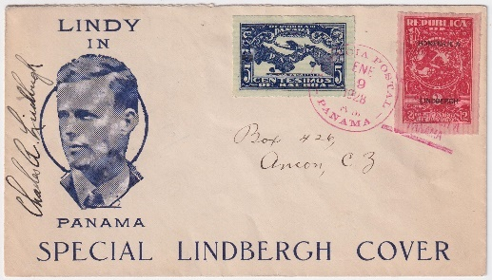
item 35130 Signed by Charles Lindbergh

Paraguay
23344 1931 1931 C74a Mint LH Imperf Pair, Signed Sanabria Underpriced!cv $35 $45.00
05291 P 1934 C88 - 92 F-VF LH 1934 ovpt $35.00
20149 1937 (Feb 17) Early Airmail Commercial Cover to France $25.00

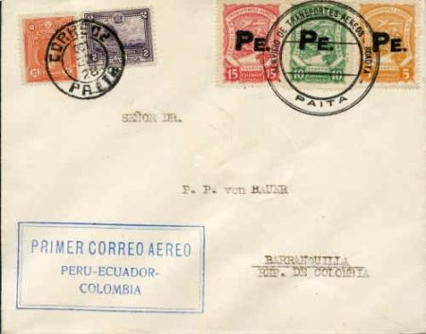
item 01964 Peru 1928 Scadta Flight Cover

Peru
01964 1928 (Oct 22) Scadta flight cover to Colombia. First flight Peru - Ecuador - Colombia. VF condition. $450.00
17369 1937 (Sep 15) Crash Cover from Faucett Air Lines, Chilla Rary, VF for this! Nierninck 370915A sfr 350. Also included is the cover used to mail the crash cover. $25.00

Poland
27951 1944-46 World War II Polish Military - three registered covers $425.00
35354 1948 #C26Cd Souvenir Sheet of 3 with Grozy Overprint, Mint cv 400 $250.00
36495 1971 (Nov 17) Apollo 15 Commemorative Cover Signed by Astronauts - Jim Irwin, Dave Scott and Al Worden. $125.00

Portugal
20334 1931 (Jan 28) Do-X flight card to New York. Frost 5I but with Portugal franking, then on to Rio (22 Jun 1931) and the to New York. Hab 5a. All postal markings on address side of VF postal card. $550.00
25641 1931 (Jan 30) Do-X Flight on VF Cover to U.S. Lisbon on board cancel (Type I) Jan 30 and red box D0-x cachet. Reverse with Brazil diamond cachet in black, Jun 22 Rio de Janeiro backstamp. $550.00

Russia
05295 1931 - 1932 C15 - C19 VF LH, imperf $250.00
09394 1935 C68b Mint VF Expertly regummed - Lowercase Cyrillic "F" Variety signed, appears NH $675.00
35348 1935 (Aug 13) Cover with C25b, 15k, perf 14, and special Leningrad Physiological Congress Cancel. Addressed to professor at Dept. of Physiological Chemistry in US, forwarded and backstamped. S. €400 as per 14 on cover. $140.00
05301 1937 C69 - C75 VF LH $60.00

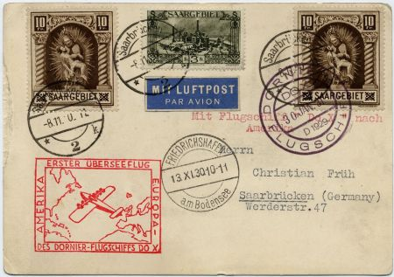
item 12768 Saar Do-X Flight Card

Saar
35347 931 Do-X Flight Lisbon to Canary Islands. Friedrichshafen 13.11.30postmark, Flugschiff 30 Jan 31 postmark. Rare 22.IV.31 backstamp indicating the mail was on board the Do-X. Frost 5 D Rio I. cv $950. Vertical crease down the center otherwise VF. $350.00
15067 1935 (Jan 13) C7 on cover to Germany. Top edge fault. $20.00
15068 1935 C5 (x2) on cover to Geislautern, Germany $15.00
02978 1953 (May 3) 1st Balloon Post of Saar, "Henri Dunant" of the Haagsche Balloon Club in Holland. FDC, special cancel, addressed to NY. VF card with Scott B95. $45.00

San Marino
05302 1951 C76 VF NH, Sassone 98 $37.50

Spain
28331 1930 (Jun 4) Zeppelin South America Return Flight, Seville - Friedrichshafen. Sent to Minneapolis, green Lakehurst backstamp on reverse S.58Ca $50.00
28338 1930 (May 17) Two matching VF Zeppelin South America Flight on Cover and Card, Seville-Lakehurst.Card has 2x 4p and cover has 2x 1p, 4p and 10p. Germany cachets sent to Chicago. €700 $300.00
42912 Spain 1938 #C91 H VF-XF Exceptional centering, signed. $150.00
14861 c.1939 C99 and C103 on airmail cover to New York signed by Heraclio Alfaro Fournier, aeronautical engineer, and aviator. $40.00

Spanish Morocco
17371 1930 (May 27) Pan American Flight Tangier - Seville, then to Friedrichshafen. Signed by Dr. Eckener! S.64XVII €2000. + $1200.00

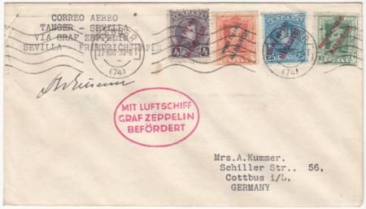
item 17371 Sp. Morocco Signed by Eckener

Suriname
12769 1931 (Mar 10) flight cover to Holland with complete airmail set C8-C14. C13-C14 with tiny period in overprint. Frost $640. Hab 17g $400.00

Sweden
08101 1919 S.19I "Bodensee" Card on board with Zeppelin message, with certificate. $3,750.00
08136 Sweden / Germany1931 "Bremen" Catapult to NY (K59SWa) $575.00
28564 1936 (Sep) 9th North America Flight Cover sent to New York and forwarded. Tiny edge tear at top. S.439 Mi €250 $200.00
28565 1936 (Sep 30) 10th North America Flight Cover Sent to New York, forwarded within US. S. 441B Mi. €250 $200.00

Switzerland

Switzerland 1923-28
22590 1923 (Aug 21) First Flight Zurich - London with C3 (x2) and 168 (x4) = .70 Small sized VF cover addressed to London. Cancel has some smudging. Very rare. SLH RF23.2d Sfr 4000 = $4350. $1,500.00
22587 / US 1926-27 (Feb 17) Pestalozzi Swiss Flight Cover with Dual Franking. US U294, 553 (x2), 554, C4 (x2), C6 = 43c sent registered from San Francisco Oct 20, 1926 through NY. received Basel Oct. 31 then with Swiss franking added, C4 (x2) on the Special Feb. 17 Flight. 30c Swiss postage due added Feb. 18. VF, combination is rare. SLH Sfr 2800 = $3050. $1,600.00
39017 1927 (May 30) Chaux-De-Fonds -Lausanne 1 First Flight on 35c Imprinted pictorial Envelope from Aviation Society with C6. Bees in Cancels $50.00

Switzerland 1929
26492 1929 (Jul 31) First America Flight Cover with C6, C10 and C12 block of 4. The cover has a light bend across bottom otherwise VF. (S.27) €235 stamps cv $134. SLH 101B Sfr.400 (previous owner paid $400) $200.00
26494 1929 (Nov 2) Swiss Flight St. Gallen Air. VF 10c postal card with C6, 160 (x2) and 168. cv $34. S.46 €30 $35.00
26495 1929 (Nov 2) Flight to Böblingen on VF postal card with C4, C11 cv $59. S.48 €340 SLH 108 Sfr.600. $250.00
36616 1929 (Aug 29) Round the World Return Flight Sent to Philippines, PPC of Pratteln. S.30Aa €200 $650.00

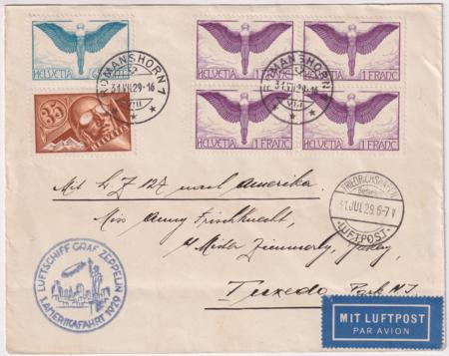
item 26492 Switzerland 1929 1stAmerican Flight

Switzerland 1930
03057 1930 (May 29) Catapult cover, legal sized, "Bremen" to Boston. 2c US postal stationery with 3c violet Tell's son large block of 32 + 2 others. Sent from Basel. 18 mailed K255 SZ cv $750. $500.00
03058 1930 (Sept 16) Catapult Cover, "Bremen" to New York. Large yellow brown cover with 2 airmails + 2 definitives. Sent registered from Zurich, addressed to Milwaukee, WI. K47SZ cv $300. Hab. 33 $200.00
05919 1930 Vaduz Flight. (Aug 18) Vaduz flight with Swiss franking, Scott 208, C5, C13 and C15. Only a handful carried, rare! S. 79 €2400 Michel 104l €2200 SLK 30Aa Sfr 4000. $2,100.00

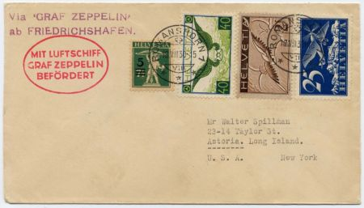
item 05919 Swiss 1930 Vaduz Flight
08002d 1930 Dortmund Flight S.77A $500.00
22582 /US 1930 (Sept 1-6) Europa Catapult Registered XF Cover. At left of cover is Bern postmark on C5, C7-9 to US. Then return flight with US C7, E14 on right side on special "Graf" cover. Interesting S/L marking on reverse., SLH K47-48 Unlisted combo but similar Sfr 800 = $800.00 $550.00
26497 1930 (May 16) South America Flight to Lakehurst Cover with C9, C12 (x10) 10.50 fr cv $243. C12 block of ten is on the reverse tied by Lakehurst backstamp. S.57N €220 SLH 116F Sfr 350 $225.00
26499 1930 (Nov 8) Karlsruhe Flight on VF Cover with C4, C5 and C15 cv for stamps $101. S.97 €375 SLH 141 Sfr. 600 $250.00

Switzerland 1931
07999d 1931 Polar Flight PC S.119F $375.00
26500 1931 (Oct 15) 3rd South American Flight Cover. Registered cover with C9-C12, C14-C15 cv $228. Backstamped Bahia, unlisted. (S.133) SL14164 $200.00
26568 1931 (Oct 17) 3rd South American Flight. VF card with C12, C14 cv $83. Pernambuco backstamp. (S.133) SLH 164 Sfr100 $70.00
26579 1931 (Aug 29)1st South American Flight Cover. F-VF cover with C4, C12 and C15 (x2) cv $157. Cover to Pernambuco, only 5 flown! Zeppelin rarity. SLH 159B Sfr. 3500. Last owner paid $4000. $1,750.00
26584 1931 (Sep 15) Dual 2nd and 3rd South American Flights on Reply Card. Switzerland C3, C10, C15 with "Assemblee de la Societe Des." postmark on 2nd SA Flight. Friedrichshafen Sep 18 postmark and Bahia Sep 21 backstamp. Then held for 3rd SA flight. Brazil franking with Bahia Oct 22 pmk and Friedrichshafen Oct 28. Unusual combination of 2nd and 3rd SA flights. Unlisted as such in SLH, similar to 162D, 164D. 5-line red cachet to rio. VF and rare from League of Nations and mixed flights. $850.00

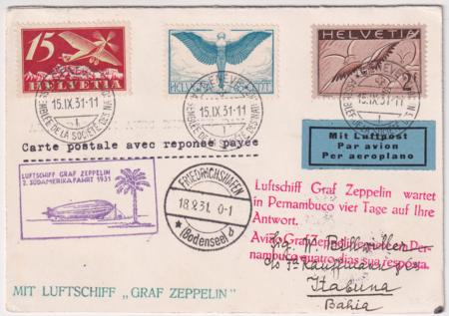
item 26584 Swiss 1931 2nd & 3rd S. Am. Flight
26674 1931 (Jul 12) Austria Flight Cover. Cover with colorful franking, C8-C10, C11 and C13. Missing back flap but otherwise VF. S.116 €85 SLH 154 Sfr. 100. $100.00

Switzerland 1932-33
26233 1933 May 26) Italian Flight on 20c XF Postal Card with C12. Rome to Friedrichshafen with Italian flight cachet. Backstamp 30.5.33.14 S.207 SLH 180D Sfr 900. Rare! $500.00
26711 / Brazil 1933 (May 6) First South America Flight with Mixed Franking on VF PPC. Romanshorn May 6 PMK with Swiss 210, C11 and C17-C18 and 1st SA blue Flight cachet. S.202 Pernambuco May 9 with Brazil airmails then Pernambuco May 13 and Friedrichshafen May 17. Last owner paid Sfr 2600 $1,400.00
26713 1933 (Jun 2) 2nd South America Flight on F-VF Cover with C15. S.214 €90 SLH 181A Sfr 150. $75.00
26714 1933 (Oct 13) Cover marked as SS Bremen Cherbourg Oct 16. Savoy Hotel Bauren Ville, Zurich cover with C14 and C17 cv $62.00 and airmail vignette. Sent to Ferguson, MO, USA. $45.00

Switzerland 1934-35
26717 1935 (Nov 19) 2nd Shuttle Flight Card with C12a and C18. Bern Nov 19 and Brazil backstamp Nov 26. S.336 €1000 SLH Sfr 1800. $800.00
26718 1935 (Jun 14) 6th South American Flight Cover to Rio. C15 cv $65. on commercially used small airmail cover with minor fault lower right. S.305 115 SLH 210 $75.00
26722 1935 15th South America Flight Cover. Complete homemade small envelope with 225 and C15a. Cover sent to Buenos Aires, backstamp Oct 27. Glue toning on reverse. S326 €150. SLH 219 Sfr 300. $135.00

Switzerland 1936
22596 1936 (Apr 23) Le Locle - Biel First Flight on XF card with C3 and B69. SLH RF36.2.b Sfr. 430 $200.00
26721 1936 (May 1) 1st North America Flight Cover with C7-C8 and C13 cv $75. S.406 €60. SLH 230 Sfr 60 $55.00
26723 1936 (May 8) 5th North America Hindenburg Flight Cover with C12a and C15a. Sent to New York. S.423 SLH Sfr. 250. $125.00
26725 1936 (Jul 29) 10th South America Zeppelin Flight Cover. Airmail envelope with C15a and C17 sent to Ascension, Paraguay. Minor faults at bottom, tear on reverse. S.360 €150. SLH 241 Sfr 350. $95.00

Baggage Labels!
Stock of early Airline baggage labels now available. Please inquire!
26728 1936 (Oct 5)10th North America Hindenburg Flight Cover. Registered cover with C12a, C21 and C25. S.441 SLH 252 Sfr 200. $100.00

Switzerland 1938
26750 1938 (Jul 26) VF Registered Airmail Cover Flims Walhaus to Buenos Aires, Argentina with 240 and C15a. $40.00

Switzerland 1940’s
01985 1947 (May 2) Swissair First Flight cover, VF condition. Printed cachet for Maiden Voyage Swissair Geneva to New York. Addressed to Littleneck, L.I. NY, backstamped Washington DC.. $25.00

Syria
05306 1920 C1 - C3 H, OG C1 Ave - Fine, C2 - C3 F - VF $475.00
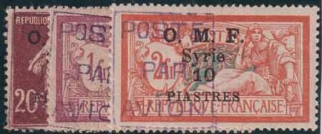
Syria
05307 1921 C4 - C6 VF LH Signed Sanabria
$750.00
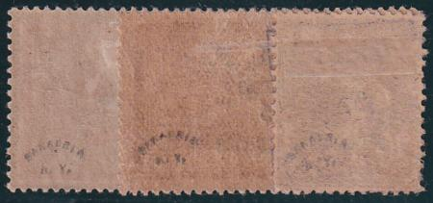

Tunisia
08035d 1933 2nd South American Flight sent to Uruguay S.214A/216 $750.00
08036d 1933 2nd South American Flight sent to Brazil S.214Aa $500.00
08037d 1933 2nd South American Flight sent to Brazil S.214Aa $575.00

United States

US 1911-1916 Pioneer Flights

07985d 1912 Ft. Recovery, OH Pioneer 47c $400.00
17200 1912 Cliftondale, MA sent to E. Saugus, MA on VF PPC showing plane flown by Harry Atwood. AAMS 29 $250. $200.00
17203 1913 Aviation Station, Sacramento CA VF card. AAMS 69 $250.00 $200.00

US 1917-19
15785 1918 (Jun 5) C3 Fine on VF Cover with Washington AMS cancel and New York backstamp. $175.00
21288 1918 (Jul 15) C2 on Washington DC to New York First Flight on cover stamped "Aerial Mail". Backstamped NY. cv $800.
$600.00
22334 1918 (Jul 15) C2 on Washington DC to New York First Flight on cover stamped "Aerial Mail". Perfect strike of cancel. Stamp is tied by black DC oval. NY 7/15, 6pm backstamp. cv $800 $600.00
28263d 1918 (May 15) C3 on First Trip Washington DC on small cover to New York. AAMC 101A1 $500.00
28264 1918 (Jul 15) First Day of Rate XF Cover from New York to Boston with C2 on corner card from Nassau Stamp Co. Stamped Aeroplane mail. AAMC RC-3 $600.00
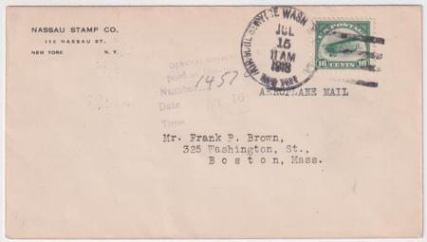
item 28264 1918 FD of Rate NY - Boston
28344 1918 C3 on Registered Cover Washington to Minnesota. Paying double First class rate of registry + special delivery and written in "to be dispatched by train”. Given the C3 included Special Delivery, the other 14c could be applied to other services: such as the 10c registry fee. There was no charge then for RR and the surface rare was 3c. The sender apparently intended to add enough postage for this double rate letter but fell 1c short. $450.00
28354 1918 (Aug 12) C2 on Washington DC to Philadelphia Flight. Advertising cover for Leonard Hi-Oven Range Company, "Bake without the 'ake'" $250.00
28360 1918 (Aug 16) C2 on Washington DC to Philadelphia Flight then forwarded by First Class mail to New Orleans. $300.00
28434 1918 (Dec 18) C2 on Washington DC to New York First Flight on cover with hand drawn cachet $250.00
28511 1918 (Dec 18) C2 on Bellefonte - NY on Corner Cover, stamped "Special Delivery". AAMC 110b $125.00
28513 1918 (Oct 29) C2 on Philadelphia - NY Flight, Small Cover. Includes note referencing mailing time $200.00
28514 1918 (Aug 2) C2 on Philadelphia - Boston Flight, addressed to Nantucket, MA. Vertical crease down cent and at right. $125.00
35128 1918 (May 15) First Flight Washington to Boston on beautiful VF blue envelope with Scott C3 and 232, 3c Columbian. Cv $750.00 $650.00
28236 1919 (Jun 4) C2 on Registered Cover from Worcester MA to Sweden via NY. Registered cover with Return Receipt Requested, censored (American #433). Sent to Krepboden (?) and forwarded to Loftahammer in Sweden. Very unusual usage for C2 $200.00
28517 circa 1919 C3 on Undated cover sent to Brooklyn and used as a Parcel Tag. Vertical crease down center. $275.00

US 1920-1926
15166 1923 (Aug 20) C3 on Government Flight 162 NY- San Francisco $75.00
15870 1923 (Aug 15) C4 FDC Sent from Washington DC to Germantown PA $250.00
15908 1923 (Apr 17) Washington DC C5 FDC Corner Card for Shoreham Hotel. Slogan cancel. $375.00
21568 1923 (Aug 15//21) C4-C6 FDC's Matched Worden Set, both stamps and covers XF! Exceptional quality. Scott $1750. $975.00
17413 1924 (Aug 19) C6 on Baltimore, MD Government Flight to San Francisco with unclaimed Return to Sender auxiliary. Small sized pink cover with Chicago Aug 20 1924 transit backstamp. Very unusual. A few small staining spots and hinge remnants on reverse $50.00

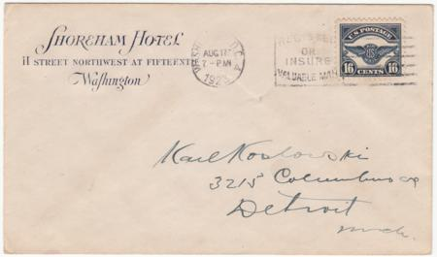
item 15908 1923 C5 FDC Corner Card
15589 1925 (Dec 1) Airmail Cover with C4 on U429, Laramie. Wyoming - New York. $175.00
12798 1926 (Dec 4) Cobham Peri-Columbia Demonstration Flight cover on U522. With 629 on the reverse. $40.00
41397 circa 1926 Photo of the Fokker "Josephine Ford" for the Byrd Arctic Expedition Signed by R.E. Byrd $125.00
41401 1926 (Apr 17) 1st Flight with C7 from Salt Lake City to Los Angeles Signed by Pilot, Charlie N James, ("Jimmie" James) $20.00

US 1927
08279 1927 (Sep 14-15) Lindbergh Day, Portland Oregon. Picture Post Card with Scott 644, shows view of Columbia Gorge and Vista House. $25.00
08280 1927 (Sep 14-15) Lindbergh Day, Portland Oregon. Picture Post Card with Scott 644 shows view of Wizard Island, Crater lake, Oregon. $25.00
08281 1927 (Sep 14-15) Lindbergh Day, Portland Oregon. Picture Post Card with Scott 644 shows view of Lao Cliff, Crater Lake, Oregon. $25.00
08283 1927 (Sep 14-15) Lindbergh Day, Portland Oregon. Picture Post Card with Scott 644, shows view of Horsetail Falls, Columbia River Highway, Oregon. $25.00
08284 1927 (Sep 14-15) Lindbergh Day, Portland Oregon. Picture Post Card with Scott 644, shows view of Vista House, Columbia River Highway, Oregon $25.00
08285 1927 (Sep 14-15) Lindbergh Day, Portland Oregon. Picture Post Card with Scott 644 , shows view of Mt Hood, Laurel Hill, Oregon. $25.00
08286 1927 (Sep 14-15) Lindbergh Day, Portland Oregon. Picture Post Card with Scott 644 plate number single, shows view of Loops of Columbia River Highway at Rowena Heights, Oregon.. $25.00
28572 1927 (Jun 27) Cover sent Air Mail via Commander Byrd's Aeroplane "America" with C7 and C9. Vertical crease on left. $100.00
34643 1927 #632 Hinged Mint VF Graf Zeppelin overprint by Roessler $100.00
36130 1927 (Oct 19) First Flight to Key West FL Signed by F4-2 Pilot, Cy Caldwell. $50.00
36136 1927 (Jan 25) C9 FDC with Postage Dues, J32.Airmail cover sent to San Francisco. $75.00
36598 1927 (Jan 25) C9 FDC Signed by Major R.W. Schroeder, Pilot. Stamped Via Air Mail and sent to Chicago. $100.00

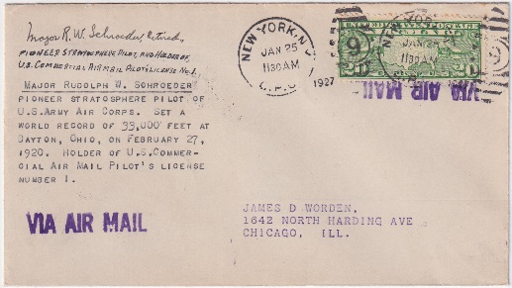
item 36598 1927 C9 FDC signed by the Pilot

US 1928
08146d 1928 "Ile De France" Catapult, Scott 518, 648 $350.00
15540 1928 (Feb 21) C4, 634a on Chicago "Lindbergh again flies the Air mail" cachet signed by the pilot, Harlan A. “Bud” Gurney $40.00
15541 1928 (Feb 21) Lindbergh Horse Shoe Flight Cover with C4 and C34, signed by pilot, Harlan A. “Bud” Gurney. $40.00
20073 US 1928 (Feb 21) "Lindbergh Again Flies the Airways" Flight with C10 Signed by Postmaster. $15.00
23073 1928 (Oct 23) Zeppelin American Flight Cover with C6 Block of 4 stamped "Expres" and sent to Baden, Germany. Friedrichshafen Nov 1 receiving cancel on reverse. Small edge tear on left $150.00
36532 1928 C11P-1 Large Die Proof—126mm x 100mm Full sized on Sunken Card—200mm x 152mm. “Approved June 18, 1928-Signed by PNG Harry S. New” which just ties the proof to card. BEP #’s 123454 + 55 on reverse. Some very minor toning-doesn’t detract. Beautiful & Rare!! Cv $11,000.00 $9,000.00

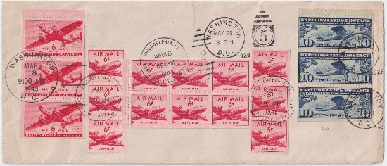
item 36625 Unique 1928//1949 Airmail FDC
36625 Unique Airmail Cover 1928//1949 - C10a, C25a, C37, C41, C39a Each Cancelled First Day. Legal Sized FDC with:
- C10a nicely centered pane cancelled Washington DC May 28, 1928
- C25a booklet pane of 3 cancelled FD Mar 18, 1943
- C37 strip of 3 cancelled FD Jan 15, 1948
- C41 strip of 3 cancelled FD Aug 25, 1949
- C39a booklet pane of 6 cancelled FD Nov 18, 1949 C37, C39a and C41 are unofficial Philadelphia FD cancels. Fabulous and unique C10a combo FDC bought from Al Zimmerman ~ 35 years ago for $450. 1/4" tear at top, 2 1/2" in from right. $750.00

US 1929
07951d 1929 Return Flight, Lakehurst to Germany to England $575.00
07963d 1929 Round the World Flight w/ Scott 547 S.28D $425.00

Ordering is easy! TOLL FREE in U.S. and Canada 1-800-947-8267 or FAX it 845-343-0068, call 845-343-5151 or email us hgitner@hgitner.com and check out our website

11538d 1929 Round the World Flight with 19c Postage Due $350.00
22593 1929 (Aug 28) Round the World Flight Cover with 567 and 571. No Flight cachet applied, Friedrichshafen backstamp Sept. 4, 1929. $65.00
22653 1929 Round the World Flight on legal sized cover with C9 (x5) and C11. No Flight cachet applied, Friedrichshafen backstamp Sept. 4, 1929. $65.00
28333 1929 (Aug 6) Round the World Flight Card on PPC of Buhl and Dime Bank Bldgs, Detroit, MI S.28B 130 $100.00
28519 1929 (Jul 20) Catapult Flight Bremen to Bremen with "NGL" perfins on 642 $125.00
28520 1929 Catapult Flight Bremen to Bremen Sent to U.S. Embassy in France $50.00
28580 1929 Zeppelin Around the World Flight Cover, Los Angeles to Lakehurst with green Lakehurst cachet on reverse. S.29A $100.00

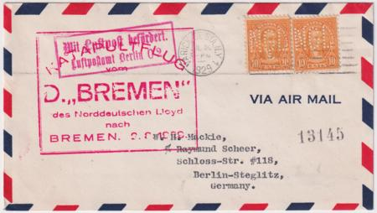
item 28519 1929 Bremen Catapult with Perfins
36116 1929 (Aug 30) Airmail Cover Signed by the pilot, Harry Sievers. Stamped " First Official Airmail Pick-Up in the US by Adams non-stop Method, Youngstown. $50.00
36138 US 1929 C10a , without tab, FDC Sent Airmail to Lancaster PA $75.00
36619 1929 (Mar) First Flight Atlanta - Miami Crash Cover $30.00
37677 1929 (Jan 12) C5-C11 on UC1 First Day Cover Signed by Harry S. New, PMG. Sent to Robert Regar, U.S. stamped envelope agent. Historic cover, backstamped Dayton, OH Jan 14. $300.00
39018 1929 (Sep 15) 1st Flight from Vancouver with C11, signed by Pilots, Joe N. Taft, George Buck. $15.00
39019 1929 (Aug 5) Round The World Flight on 5c postal stationery with 12 stamp franking; 548, 565, 566, 568, 569, 616, 618, 619, 645, 650, 654 ,C7. Great large hand drawn cachet of Zeppelin as a fish. Reverse has a paper thi8n but still a very interesting and unusual cover. $175.00
41399 1929 (Aug 29) Air Meet Cover from South Bend, IN with 650 Signed by Blanche Noyes, Aviator. $125.00
41403 1929 (Sep 15) 1st Flight from Seattle Signed by 5 Hindenburg Crew Members. Two of the crew members who would later be on the Hindeburg that crashed signed this envelope commemorating the first Air Mail flight in 1929: Afred Grozinger, a cook, and Al Stoffler, the pastry chef. The envelope is signed also by three crew members of other airships, Norbert Heiss, who served on LOZ127; George Holl, a member of the LZ127 and LZ129 crews, and Jos. (Josef) Sonntag, a mechanic on LZ127, which was in service from 1928 until it was retired in 1937. $250.00

US C13 – C15
Large stock of stamps and covers in all conditions from Superb to minor faults. Please inquire!

US 1930
03358 1930 (June 2) C14 F-VF on cover to Germany. Both German and US flight cachets are somewhat light strikes. Cover has a vertical crease on left. Friedrichshafen June 6 backstamp. S.64G $350.00
03433 1930 (May 11) C14 VF on flown "Morrison Hotel" pictorial advertising cover with additional franking, C12 from St Louis, MO. Friedrichshafen June 6 backstamp, addressed to Long Orange, NJ. Some water staining at right which doesn't affect the stamp $400.00
03434 1930 (May 3) C14 faulty (minor creasing) on damaged cover with an additional torn C11. Sent from Phoenix, AZ, addressed to Eldena, Ecklenburg in Germany. Friedrichshafen June 6 backstamp. priced as a stamp only $275.00
03438 1930 (May 31) C14 VF from Lancaster, PA cover flown to Seville. Unusual with lovely CDS hand cancel! Backstamped Seville, Spain June 5 and Lancaster, PA June 17. Minor cover staining. $450.00
04274 1930 (May 6) C14 VF stamp on VF blank card with stencil inscription cachet. $375.00
04277 1930 (June 2) C14 F-VF stamp on VF cover to Basel, Switzerland. "Duby the Florist, The Orchid" corner card on reverse. Larger European sized envelope. $375.00
07949d 1930 UC1 and C12 to Siam $300.00
08143d 1930 C9 "Bremen" Catapult to Indochina $575.00
08144d 1930 Scott 556, 558, 562 Bremen Catapult Indochina $475.00
08528 1930 C15 FDC VF stamp on flown First Day on lightly toned cover with handwritten cachet, 1/4 tear at left $600.00
11529 US 1930 "Bremen" Catapult to French Indochina $500.00
12799 1930/31 UC1 cover signed by pilots Jessie M.K. Miller, William Lancaster and Lewis A. Yancey. Cover has The New York Aviation Show cachet but is not postmarked. $150.00

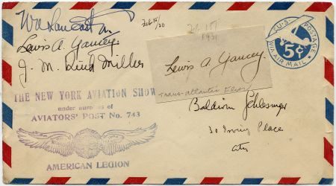
item 12799 US UC1 Signed by Pilots
13927 C.1930 Mint Airmail Cover signed by pilot Frank Hawks $75.00
15566 1930 C13 FDC on Registered Airmail Cover $700.00
15574 1930 Mint Airmail Cover Signed by Pilot Shirley Short. $20.00
19219 1930 (Apr 30) VF PPC of Washington monument with C13 -C14, scarce Round Trip with 1.95 rate. S.64A + B ll $550.00
19835 C14 Airmail XF NH Natural Inclusion Spot on Reverse + Over $540.00
20826 1930 (May 31) C14 F-VF on Legal Sized PPC of Milwaukee View by Northwest Airlines. Sent Lakehurst to Friedrichshafen with small boxed printed cachet. Some minor toning. Beautiful card! $425.00
20974 UC1 Airmail Unflown Cover Signed by Aviator Amelia Earhart. Small magazine photo cachet added on. $875.00
21228 1930 (May 31) C13 XF Zeppelin Flight PPC, Picture of Ambassador Bridge, Detroit, Michigan. $200.00
21284 C13 P1 Airmail Essay - 65c Graf Zeppelin Die Proof - Unique Variant likely from estate of engraver. Razor sharp detail as any would expect. Originally 74 x 53 mm mounted on larger card by brown tape now trimmed off. Now 59 x 53 mm - Beautiful and Pristine. Only 3 sets are known of C13-15 Large Die Proofs. Accompanied by original mounting card. $11,000.00
21667 1930 (Jun 2) C14 on Small Sized F-VF Cover from Brooklyn $375.00w
21668 1930 (Apr 28) C15 on VF Flight Cover, addressed to Brookline MA. Green Lakehurst receiving cancel. $575.00
22303 1930 (Apr 19) C14 VF on FDC Flown South America Flight Card. Green Lakehurst receiving cancel on front and Nickel's stencil lettered cachet. $600.00

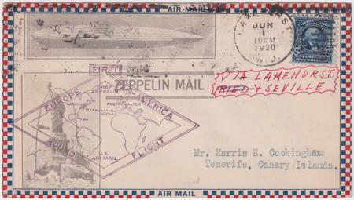
item 22578 US 1930 Flight to Seville
22578 1930 (Jun 1) Pan America Flight on VF Roessler cacheted cover to Tenerife Canary Is. with 479, FR9 Minnesota Federal Reserve Bank Perfin. Flight to Seville is backstamped June 5. Receiving mark from American Consulate in Tenerife. Very unusual! $475.00
22936 1930 C15 (CF1) Mint H Panelli Forgery with Gum Added (issued ungummed) Scarce. cv $1500. $1,300.00
22937 1930 C15 NH OG Superb, Grade 98 with PSE Certificate. cv $5,000. $4,250.00
23199 1930 (May 31) C13 - C15 Set on Legal Sized Pan America Cover to Germany. VF Flown cover from Hudson Terrace, neatly opened at bottom. $1,400.00
24847 1930 (Jun 2) C14 on Zeppelin South America Flight Cover with all proper postmarks, Friedrichshafen backstamped. $375.00
25649 C14 Airmail VF NH Plate Block #20086. Pristine NH but gum slightly short at right. A few perfs expertly rejoined in selvedge. $3,250.00
25651 1930 (May 7) C14 on XF Roessler Flight Cover to Seville with Roessler Cachet. Sent to/from Roessler. Backstamp and forwarding cancel on reverse. Only 326 covers flown, stamp F+. $475.00
27948 1930 VF C14 (x2) on Flown Zeppelin Cover to Colorado. Stamps are VF, cover is XF in pristine condition. cv $725 $675.00
27950 1930 (May 10) C13 VF/XF Chicago Flight on PPC. Stamp is VF/XF and card, picturing view from Lake Michigan, has a few corner dings. $175.00

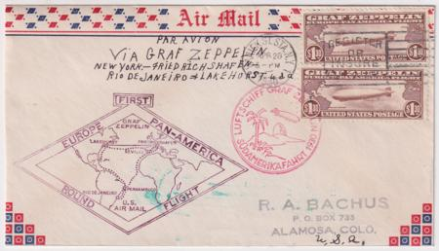
item 27948 US C14 VF Stamps on XF Cover
28332 1930 Card from Johnson-Clark Stamp Co. in Minnesota advertising upcoming special Graf Zeppelin air mail stamps $50.00
28335d 1930 (Apr 24) Pan Am Flight on 1c Postal Card with Additional $1.29 Franking. The added franking is on the reverse for a total of $1.30. $250.00
28505 1930 (May 30) C13 VF stamp on unusually large post card. Green Lakehurst receiving cancel on reverse $195.00
28506 1930 (May 30) C14 Fine Stamp on XF Cacheted Cover. Addressed to Arkansas with Lakehurst green receiving cancel on reverse. $375.00
28507 1930 (Apr 30) C15 VF Stamp on F-VF UC1 Cover sent to Illinois. With green Lakehurst receiving cancel on reverse. $500.00
29283 1930 (Jun 13) Registered cover with C11 (x4) Stamps are tied by two strikes of solid airplane fancy cancel #836 in black. The cover is overall toned. $100.00
30128 1930 (Apr 29) C15 VF Stamp on VF Airmail Cover sent to Lakehurst, NJ. With green Lakehurst receiving cancel on reverse. $500.00
30129 1930 (Apr 29) C14 Pair Fine on VF Airmail Cover to Lakehurst, NJ. $575.00
30130 1930 (Jun 6) C13 VF on VF Postal Carl to NJ $185.00
30596 1930 #C15(CF1) MINT XF Large Die proof in Purple unlisted in orange 2000 $2000.00
30728 1930 Apr 29) C15, F-VF on VF Flight Cover from Washington DC to Paterson, NJ $550.00
30709 C15 (CF1) MINT F - VF Panelli Forgery Large die proof in green unlisted $1,800.00
36118 1930 (Dec 6) Airmail Cover with C12 Signed by the Pilot, Walter Hinton $25.00
40275 circa 1930 Photograph (~5" x 3.25") Signed by Early Aviator Bill Alexander $20.00
41293 1930 (Sep 1) 1st Flight Cover with C12 Signed by Amelia Earhart. Airmail cover for First hourly aeroplane passenger service Newark-Baltimore-Washington-Philadelphia. $1150.00
41294 1930 USS Airship Akron Airmail Label Printed by Roessler, mint no gum. $10.00
41395 1930 C13 VF on F-VF Zeppelin Flight PPC , Picture of Michigan Ave from Lake Michigan. Sent to Oak Park, IL. Card has corner crease in upper right corner. $175.00
41396 1930 C13 F-VF on VF Zeppelin Flight PPC , PC of Graf Zeppelin in Hangar. Sent to Germany. $200.00
41723 1930 (Apr 29) C15 VF Stamp on VF Cover sent to Long Island, NY With green Lakehurst receiving cancel on reverse. $500.00
42797 1930 (Apr 19) C13-C15 Flown FDC Set, F-VF or better stamps on XF fresh Covers. C13 on card, C14-C15 on covers. $1,600.00

US 1931
12169 1931 (Jan 24) Airmail cover with C12 and Earle Ovington autograph. Experimental ship to shore flight with first airmail pilot cachet. $95.00

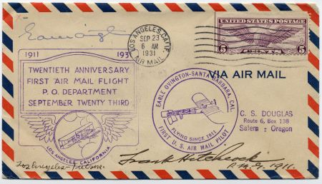
item 12975 US Signed by Pilot Earle Ovington

12975 1931 (Sep 23) The Anniversary of the First Airmail Flight with C12 signed by the pilot, Earle Ovington, and the postmaster. $95.00
12996 US 1931 Earle Ovington on 20th Anniversary First Airmail Flight cover with C12. $95.00
14830 1931 (May 21) C12 on cover signed by Early Bird Pilot, Lt. Col. Richard B. Barnitz $20.00
19856 1931 (May 12) Catapult Cover, S.S. Bremen - Southampton. Ship to Shore Service, addressed to Bremerhaven Germany. $60.00
28566 1931 (May 12) Bremen Catapult cover to Southampton with 640, 685 (x 3) and addressed to Switzerland. K60a $75.00
28567 1931 (May 18) Catapult Cover Europa - Southampton with 635, 697 and addressed to Switzerland. $65.00
35355 1931 "The Story of the Airship" 7th Edition by Hugh Allen, with inscription on cover. 84 page book with photos. $35.00
40276 1931 (Dec5) Air Show Cover with #703 and 653 Signed BY Aviator, author & inventor, Al Williams and by Col. J. J. Grady $90.00
41391 circa 1930’s Amelia Earhart Cut Signature $550.00
41398 1931 (Sep 7) National Air Race Cover Signed by Florence Klingensmith, Pioneering Aviator who died in 1933. $175.00
41405 1931 (Mar 15) Charlotte Air Tour Cover with C12 Signed by Col. J. J. Grady and 6 Others $20.00

US 1932
12984 1932 (Jul 2) Autographs of Jack Bishop, pilot, and Mrs. Floyd Bennett on Airport Dedication Airmail cover with Scott 710. $75.00
14303 1932 (Dec 3) Lebanon, Pennsylvania Gordon S. Light airmail cover with Scott 627 and 725 and two strikes of Airplane fancy cancel N-459 in blue. $75.00
15576 1932 (May 18) C12 on Anniversary of 1st Flight Signed by Pilot, Bob Leroy, co-pilot F.F. Church and others. Cover is overall toned. $25.00
21419 1932 (Sep 14) U525 Cover Signed by Roscoe Turner, Aviator. Vertical crease down center and toning on edges. $50.00
28521 1932 (Jul 27) Catapult Cover Bremen - Southampton with C10 pair addressed to Switzerland $100.00
28522 1932 (May 27) Catapult Cover Europa with 713, 715, 717 - Southampton addressed to Dr. Robert Paganini, friend and benefactor to Stephen Smith, rocket pioneer. $75.00
28569 1932 (Sep 22) Catapult Cover Europa - Southampton with C8, C12 and addressed to Switzerland. $100.00
35132 1932 (Apr 2) National Aircraft Show Cover with plate number single of C12 and special Aircraft show blue vignette. F-VF cover is signed by pilots Ralph R. deVore, Edwin L Preston and one other. Addressed to Albuquerque, NM $25.00
41407 1932 (Aug 27) National Air Races Cover Signed by Aviator, Mildred Morgan, Aviation Pioneer and Air Racer $90.00

US 1933
07968d 1933 Scott 701 Chicago flight round trip $375.00
07971d 1933 C18 FDC Chicago flight, special delivery $325.00
07973d 1933 (Oct 2) Century of Progress Flight with Scott 701 (3x) postmarked $450.00
08145d 1933 "Europa" Catapult to Germany UX27, 639, 642 $250.00

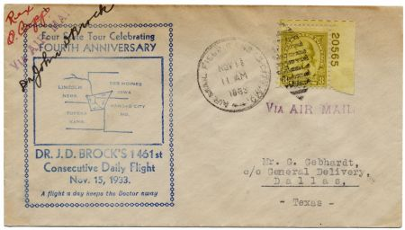
item 08587 19322 Signed by Pilot Dr. Brock
08587 1933 (Nov 15) Cover with 713 PNS for the fourth anniversary of consecutive daily flights signed by amateur pilot, Dr. J.D. Brock. He was called The World's Most Prolific Pilot $125.00
11544d 1933 1934 NY to Rome Flight $425.00
14898 1933 (Oct 7) C18 on Century of Progress Zeppelin cover from Chicago to Friedrichshafen $150.00
15881 1933 (Oct 5) C18 FDC Washington DC, Scarcer Fairway Cachet, blue First Day and Silver Zeppelin. Brookman 400.00 $350.00
17380 1933 (Oct 6) C18 XF stamp on VF FDC to 13Chicago, Signed by A. Pittman, Postmaster. $110.00
19857 1933 (Oct 4) C18 Pair on Zeppelin Chicago Flight from New York $95.00
21326 1933 (Jun 3) 728 & 729 5th Anniv Flight of 1st Airmail CAM 17 Toledo, Ohio Signed by Pilot, Harold L. Knoop. $10.00

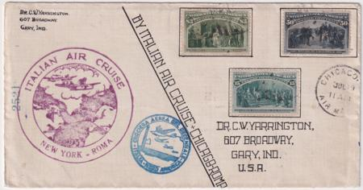
item 21571 US 1933 Balbo Chicago to Rome
21571 1933 (Jul 19) Balbo Chicago to Rome Return Flight with 15c, 50c and $3. 1892 Columbus Stamps. Unique Franking! While it has the correct blue Italian flight cachet on front and proper transit flight and receiving backstamps on reverse, the New York / Rome US flight cachet was applied in error (rather than Chicago -Rome) making it a truly unique Balbo flight cover for the Balbo connoisseur. $2,500.00
22335 1933 (Nov 22) C20 FDC Flown San Francisco to Manila. Beautiful unique four color hand painted cachet Priced on reverse for $1500. $350.00
25599 1933 (Jul 18) Balbo Italian Air Cruise Chicago - New York. Backstamped NY July 20. $850.00
27801 1933 (Oct 2) Zeppelin Chicago Flight, NY -Friedrichshafen. Sent to Washington DC. $250.00
28570 1933 (Oct 6) C18 FDC Miami, FL to Chicago, Addressed to Minnesota. S.242B €175 $125.00
35757 1933 C18 Post Office Announcement, folded $35.00
36600 1933 (Jul 18) Balbo Flight Cover to Canada with $1.70 franking and 3 Canadian backstamps. Minor faults including bottom tear and staining. Still a very scarce cover! Only 37 flown. cv $1,000.00 $375.00
36602 1933 (Feb 11) First Flight Detroit, MI to Buffalo, NY. 27E39f $30.00
39022 1933 (Jul 23) NY - Rome Balbo Air Cruise Cover with Rare Official Seal. Endorsed in manuscript "By Italian Air Cruise, New York to Rome". Italian Air Cruise flight cachet and blue flight cachet. $1,250.00

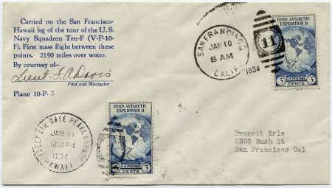
Item 12900 US 1934, Signed by Pilot F.A. Davis

US 1934-1935
08131d 1934 Catapult 557, 698 (2) Bremen Catapult to Berlin then forwarded to Aden, British Somaliland! $750.00
12900 1934 (Jan 10-11) Navy Flight with 733, San Francisco to Hawaii signed by pilot and navigator, Lt. F.A.Davis. $250.00
13181 1934 Mint PPC Signed by Pilot, Eddie Gerber $60.00
20076 1934 (Jul 1) C19 on First Day of 6c Airmail Rate $15.00
21327 1934 Omaha Air Race Cover Flight Signed by Pilot, Roger Don Rae $40.00
23059 US1934 (Feb 13) C18 Block on Registered Non-Flight usage, over franked, to Portland. Cover arrived in Portland the next day! Delivered on the 15th. cv for a used block is $275. $250.00
36132 1934 USS Macon Cachet on Airmail Cover Signed by Rear Admiral Simpler U.S.N $15.00
08277 1935 (Jul 11) C19 block of 4 on oversized cover with hand drawn airmail border addressed to Franklin D. Roosevelt at the White House. Large 8.75 " x 11.25" manila envelope with 2" tear from the bottom edge. $50.00

US1936
08120 US / Germany 1936 9th North American Return Flight & 10th North American Flight. S439 A/B + S441 A/B $675.00
12516 1936 (May 16) small rocket mail cover, serviced by Roessler. Cover has 632 on front and 634 on back. $100.00
13255 1936 (Sep 8) UC28 Portland OR airmail cover signed by the pilot $15.00
27848 1936 (May 11 1st North America Hindenburg Flight to Paris, Forwarded. Vertical crease down center $100.00
29901 1936 (Apr 13) CE1on Airmail Cover Signed and dated by Alaska Bush Pilot, Joe Crosson $30.00
35134 /Germany 1936 First North American Hindenburg Flight to US and back. Set of two unusual message/reply cards prepared by Agent Kummer in VF condition. Each has a different receiving cancel. $250.00

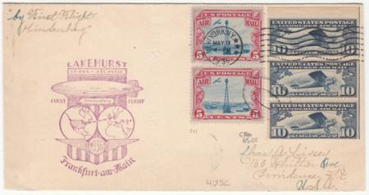
US 1936 1st N. Am. Hindenburg with C10a
20079 1936 (May 11) First North America Hindenburg Flight with C10a booklet pane + C11 (x 2) S.405C $350.00

40280 Circa1936 Airmail Cover with #785 Signed by Pioneer Aviator Dick Merrill. Uncirculated cover. $85.00

US 1937-1939
13260 1937 UC28 1937 (Jul 6) UC28 Oregon Air Tour cover signed by Pilot $15.00
36140 / Brazil / Netherlands / Malaya 1937 (Apr 19) Pan Am / KLM Around the World Large Cover. 1st flight FAM 14 San Francisco - Hong Kong + more. The cover has some edge flaws. Sold on ebay for $500. $200.00
15588 1938 (Mar 7) Cover with 791 Signed by Pilot J.G. Johnson, future Admiral. Signature is on the back of the cover. $35.00
17720 1938 (May 20) C23 on National Air Mail Week Cover Signed by Pioneer Aviator Hugh A. Robinson $50.00
25245 1938 (July 10) Howard Hughes Round the World Flight on airmail cover with Harry Connor autograph. The cover has US C19, C23; France C8 and Russia 639. All four stamps tied by cancels. $2,250.00
28576 1938 (May 31) Small airmail cover from Honolulu, Hawaii with 2x C21, the 40c Interim Rate. "Mailed at Midway Island, Pan American Airways System" circular cachet6 on front and back. $175.00
22592 1939 (May 16) C24 FDC on beautiful Moesser Hand painted cacheted cover. Rare and spectacular , previous owner priced it for $575. $325.00

US 1940’s
36603 1946 (Aug 19) First Flight Charleston, SC to Charlotte, NC on Airmail Cover with Scott 928 + 934 $20.00
40283 Circa 1946 Cut Signature of First Army Pilot Frank P. Lahm. Aviation pioneer and 1st military aviator. $25.00
08052 1949 UXC1a VF+ Full deep red, (cv $550.00) $275.00
14209 1949 (Dec 17) C45 FDC signed by General Nathan F. Twining, Air Force Chief of Staff, with magazine photo cachet. He later became the Chairman of the Joint Chiefs of Staff. $100.00
14851 1949 (Feb 1) 811 on NY airmail cover signed (on front and back) by William a Denehie, pilot and aeronautical engineer. Cover has Early Bird cachet. $25.00
36604 1949 (Jan 30_ First Flight Seattle, WA to Suva, Fiji on Airmail Cover with C36 $20.00
36606 1949 (Jan 30) First Flight Portland, Or to Canton Is. on Airmail Cover with C39 $10.00

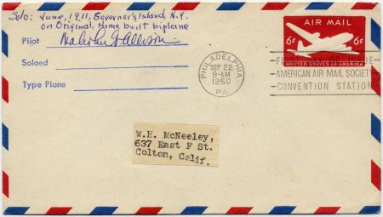
item 14854 US 1950 UC18 Signed by Pilot

US 1950’s
14854 1950 (Sep 22) UC18 FDC signed by pilot Malcolm G. Allison. $20.00
28361 1950 (Mar) Washington to Minneapolis Crash Cover, missing 3x prexie. Accompanying post office letter about recovered mail. $200.00
40281 1950 Cut Signature of Early Bird Aviator Hugh A. Robinson. $25.00
14211 1953 (May 29) C47 FDC signed by Earl N. Findley, editor and early aviator. $40.00
14213 1953 (May 29) C47 FDC signed by Roscoe Turner, early aviator $75.00
14214 1953 (May 29) C47 FDC signed by Vice Admiral Patrick N. L. Billinger, aviation pioneer. $75.00
14217 1953 (May 29) C47 FDC signed by Berkwith Havens, early pilot. $40.00
14220 1953 (May 29) C47 FDC signed by Frank T. Coffyn, aviation pioneer. $65.00
28649 1953 (Jan 5) 1016 on Cover Signed by Donald Douglas Sr, Aviation Pioneer and founder of Douglas Aircraft. Added magazine cutout on reverse. $120.00
19917 1954 Air Show Cover with C47 Signed by Pilot Andrew M. Surini, Early Bird Aviator 5/16/54 $20.00
19918 1954 Air Show Cover with C47 Signed by Pilot Richard N. Swenson, Early Bird Aviator 5/16/54 $20.00

US 1960’s
40289 Circa 1960 Photo (8.5" x 10") Signed by Captain Harold "Blackie" F. Blackburn, Pioneer Aviator in WWll and TWA pilot. $40.00
26047 1961 UC35b Postal Stationary var - missing blue.cv $1000. PF certificate $900.00
26048 1961 UC35a Postal Stationary var - missing red.cv $900. PF certificate $800.00
14221 1962 (Feb 20) 1193 uncacheted FDC signed by Mrs. Robert H. Goddard, wife of inventor of first liquid fuel rocket. $25.00
36608 1963 C50 on Certificate of Mailing $25.00
41295 1963 #1231 Plate Block Signed by NASA Astronaut, Russell L. Schweickart $60.00
40288 1964 (Mar 17) #C64 on Airmail Cover flown via Helicopter & Signed by Pilot Joan Merriam. She was known for solo flight around the world. $65.00
16562 1965 (Mar 23) Rocketpost Card with C67, Signed by George S. James and Harry H. Mueggenburg. $25.00
36609 1965 (Mar 23)Two California Rocket Mail Covers Honoring Landing of 1st US Gemini Mission. EZ 62-C1A + 2A $25.00
14857 1968 (Sep 8) C74 on New Madrid Airport Dedication cover signed by pilot Bobbi Trout, early woman aviator. $35.00
22575 1968 (May 15) C74 FDC Signed by Pioneer Aviator Bill Hackbarth. $40.00
12071 US C76 on FDC Signed by Apollo Project Director, Rocco A. Petrone. $20.00
29519 1969 (Sep 9) C76 FDC Signed by Thomas O. Paine, NASA 3rd Administrator and Sam C. Phillips, Lt Gov, Apollo Program Director NASA 1964-69. And cancel for Moon Landing Jul 20, 1969 $125.00

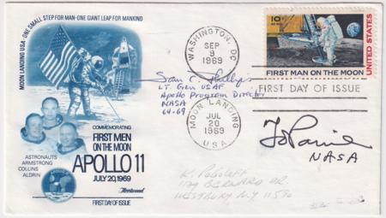
item 29519 US 1969 C76 FDC Signed

US 1970’s -1980’s
40286 1971 (May 6) UC43 FDC Signed by Aviator Chuck Yaeger, Test pilot and in 1947 became the first pilot in history confirmed to have exceeded the speed of sound in level flight.. $100.00
19919 1974 Cover Signed by Bob Reeve. commemorating 42 years Alaskan pilot, 08/27/74 $45.00
22801 1975 (Jul 4) 1563 on Flown Hot Air Balloon Cover Signed by the stamp designer, Brad Thompson. $75.00
40758 1975 (Feb 28) #1556 FDC Signed by Charles J. Hall, Pioneer Project Manager $25.00
29898 1976 (Mar 19) Scott 1684 FDC Signed by John McLucas, Federal Aviation Administrator. $35.00

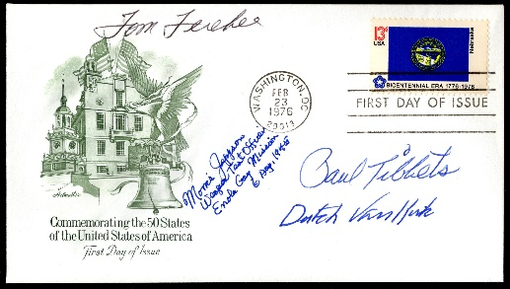
item 42132 4 Crew members of The Enola Gay
42132 1976 (Feb 23) #1669 FDC Signed by Crew of Enola Gay - Paul Tibbets , pilot; "Dutch" Van Kirk, navigator; Tom Ferebee, bombadier and Morris Jeppson, assistant weaponeer. Sold with certificate. $325.00
40287 1977 Sep 18) #4164 on 60Th Anniversary of US Air Force Cover Signed by Dutch Van Kirk, navigator on the Enola Gay $50.00
29525 1978 (Jul 20) 1759 FDC Signed by Kermit S. Watkins, Viking Project Manager. $40.00
29526 1978 (Jul 20) 1759 FDC Signed by Dr. Gerald Soffen, Chief Scientist for Viking Project. $25.00
36119 1978 (Jul 20) #1759 FDC Signed by Dr. Gerald Soffen, Chief Scientist, The Viking Program $25.00
15594 1980 C99 FDC Signed by Designer, Paul Calle. Cover is uncacheted $65.00
17549 1980 (Apr 6) 1710 + 1582 on Unaddressed Cover Signed by General Leigh Wade, Pilot. $50.00
40284 1980 Dec 30) C99 & C106 FDC Signed by Aviator Chuck Yaeger. Test pilot and in 1947 became the first pilot in history confirmed to have exceeded the speed of sound in level flight. $100.00
40278 1986 (Jul 25) Airmail Cover with C58, 1044A and 1035 Signed by Pilot & NASA Astronaut, Loren Shriver. $25.00
29912 1988 (May 14) C118 FDC Signed by Richard Peterson , Director of NASA Langley Research Center. $30.00
29913 1988 (Jun 23) C119 FDC Signed by Eugene Buckley, President Sikorsky, Aircraft Corp. $25.00

Puerto Rico
13164 Puerto Rico1934 Early Arimail Cover with 637 on UC2 variety, Wmk 33, sent to San Francisco. Mendez and Compania corner card cv 750.00. Sold with PF certificate. $450.00
21292 1938 (May) C23a Legal Sized Airnail Cover for National Air Mail Week with Puerto Rico Aerovias Nacionales Semi-Officials Label in red. $100.00
18092 1940 (Jul 26) C7 pair on commercial cover to NYC with 3c "Aerovias Puerto Rico Inc." Semi Official Airmail tied by purple oval hand stamp. Very Scarce. $150.00
18090 1941 (Sep 9) US 899-900 + Aerovias Puerto Rico 1c-50c Semi-Officials triangle airmails on local cover Ponce to San Juan. Airmails tied by Air Co. violet oval hand stamp. Rare! $250.00

Uruguay
28242 937 (Jun) 250th Condor - Lufthansa Registered Flight Card sent to Sieger in Frankfurt, Germany. $80.00

Yugloslavia
05313 Lubiana June 1941 Italian Occupation, Sassone 57 - 60 F-VF NH Raybaudi certificate. Unlisted in Scott. Only 1106 issued! $750.00
05310 Trieste, Zone B 1953 C21 XF NH Block of 4 with Esperanto Congress ovpt. In top margin $700.00

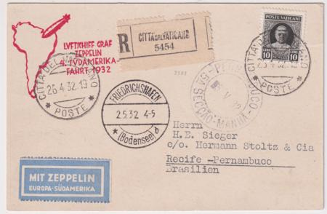
Vatican 1932 4th S. Am. Flight on PC

Vatican
27850 Vatican 1932 (Apr 25) 4th South American Flight on Postal Card. Registered card with Friedrichshafen and Pernambuco receiving cancels on front. Only 41 flown. S. 157Aa €950 $750.00
08099 1951 Rome Crash Cover with official outer envelope. $400.00

Zanizabar
08038d 1934 10th South American Flight sent to London, then Germany to Brazil S.28Aa $1,750.00

Autographs
36367 US 1962 Commemorative Leaflet as guest of honor at reception held by Acting Secretary General Uthant. Franked with UN 47-48 and pm Mar 2 1962, New York and signed by John Glenn, aviator, astronaut, businessman, and politician. $150.00
05762 Jose Larios 1985 Spanish Ace, Signed biographical re print $50.00
05764 Autographs Yan Reznnak 1972 Signed Photo $50.00
05763 Early Autographs Stefan Marinopolski 1984 Bulgarian Ace, signed on reproduction photo $80.00

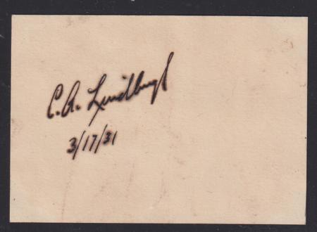

25914 US 1931 Cut Autograph of Charles Lindbergh, dated 3/17/31 $675.00
35284 circa 1930 Autographs for Lithuanian aviators Captain Stephen Darius and Lieutenant Stanley Girenas. They were both killed on flight from NY to Lithuania in 1933. Cut signature with newspaper clippings $125.00

TERMS OF SALE
Payment Methods: $US; cash, check, money order, bank transfer, credit cards (Visa, M/C, AmEx, Disc).. Outside the US, please ask.

Sales Tax: All orders shipped to NY addresses must add sales tax. Please indicate county.

Shipping: Shipping fees include careful packaging as well as private insurance. Special shipping requests may be extra. Overnight and fast delivery are available at reasonable prices.
Shipping within the US: All orders are sent by first class, numbered mail, or UPS, according to value and size.

$1.00 - $99.99 $3.50
$100.00.- $499.99 $7.50.
$500.00 + $9.50

Shipping outside the US:
$1.00- $99.99 $8.00
$100.00 - $499.99 $20.00
$500.00 + $25.00
SATISFACTION GUARANTEED! Any item that does not please you may be returned for a prompt refund or exchange.

1933-34 US Flight to Rome - Crash in Ireland
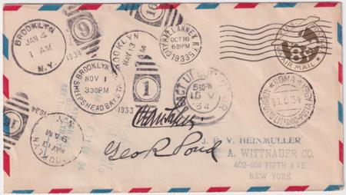
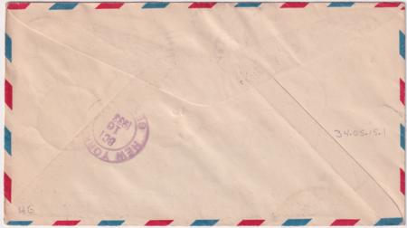
Item 21572 US 1933 (Oct 16). 1998 Irish Crash Airmail Catalogue # 34.05.15.1. One of the many different variations of the basic type of Flight cover. Signed by Cesare Sabelli and George Pond, the pilots. $450.00

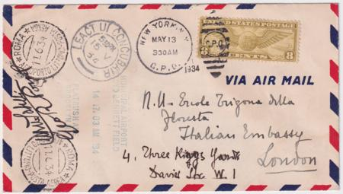

Item 21573 US 1934 (May 13). 1998 Irish Crash Airmail Catalogue # 34.05.15.1 variety. Unusual with C17, not UC8. Specially sent to London to the Italian Ambassador and not further mailed back to NY. Possibly unique as such to London. Signed by Cesare Sabelli and George Pond, the pilots. $600.00
George R. Pond and Cesare Sabelli attempted a “Non-Stop” Transatlantic Flight to Rome, Italy 1933 from New York that, due to the crash in Ireland and subsequent repairs, didn’t arrive in Rome until June 11, 1934
The Four Covers we have listed on our price list and web site are new to the market. They were discovered several years ago among a remainder part of the Estate of John A. Klemann, Nassau Stamp Co., active 1849-1941. They were among the largest stamp dealers in the US in the 1900’s-1930’s and handled many important properties including the “Earl of Crawford” U.S. collection, Grinnell Hawaii Missionaries, and countless others. He was famous for his lowball offer of the C3a airmail invert sheet and owned the discovery sheet of C3 grounded planes.
This flight is best described in the 1998 Irish Crash Airmail Catalogue by Ronny Vogt whose numbering system we use. AAMS uses TO #1207.0 See the link on our website (under Pricelist, scroll down to Topicals) to the nine pages of history, listings and photos: https://www.hgitner.com/pdf/Irish-Crash-Airmail-Pages.pdf
Our thanks to the author. All covers listed are VF/XF with genuine autographs
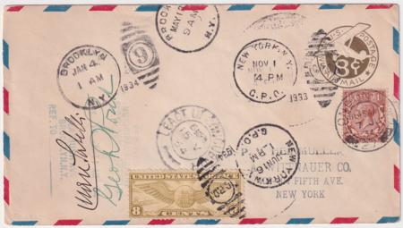

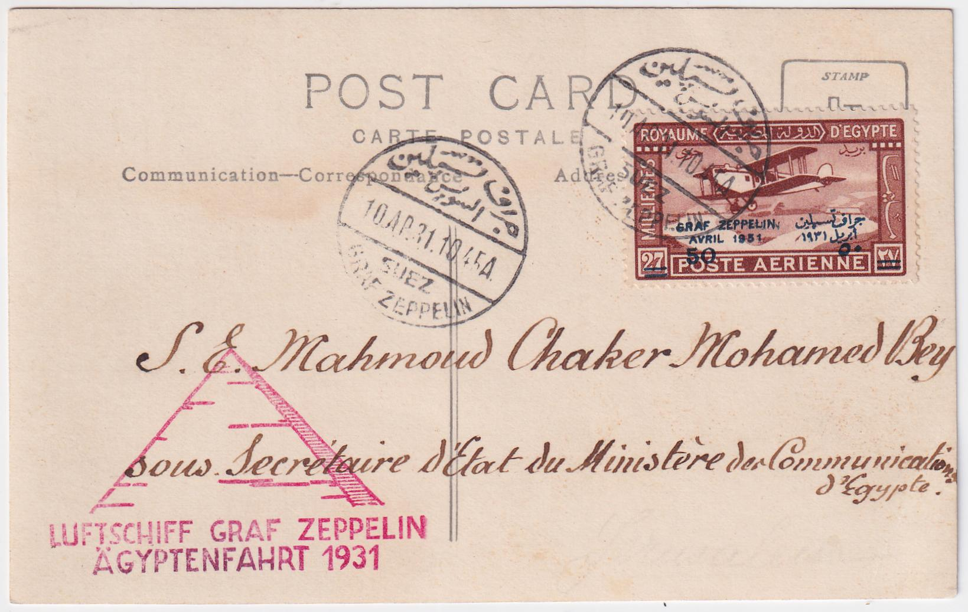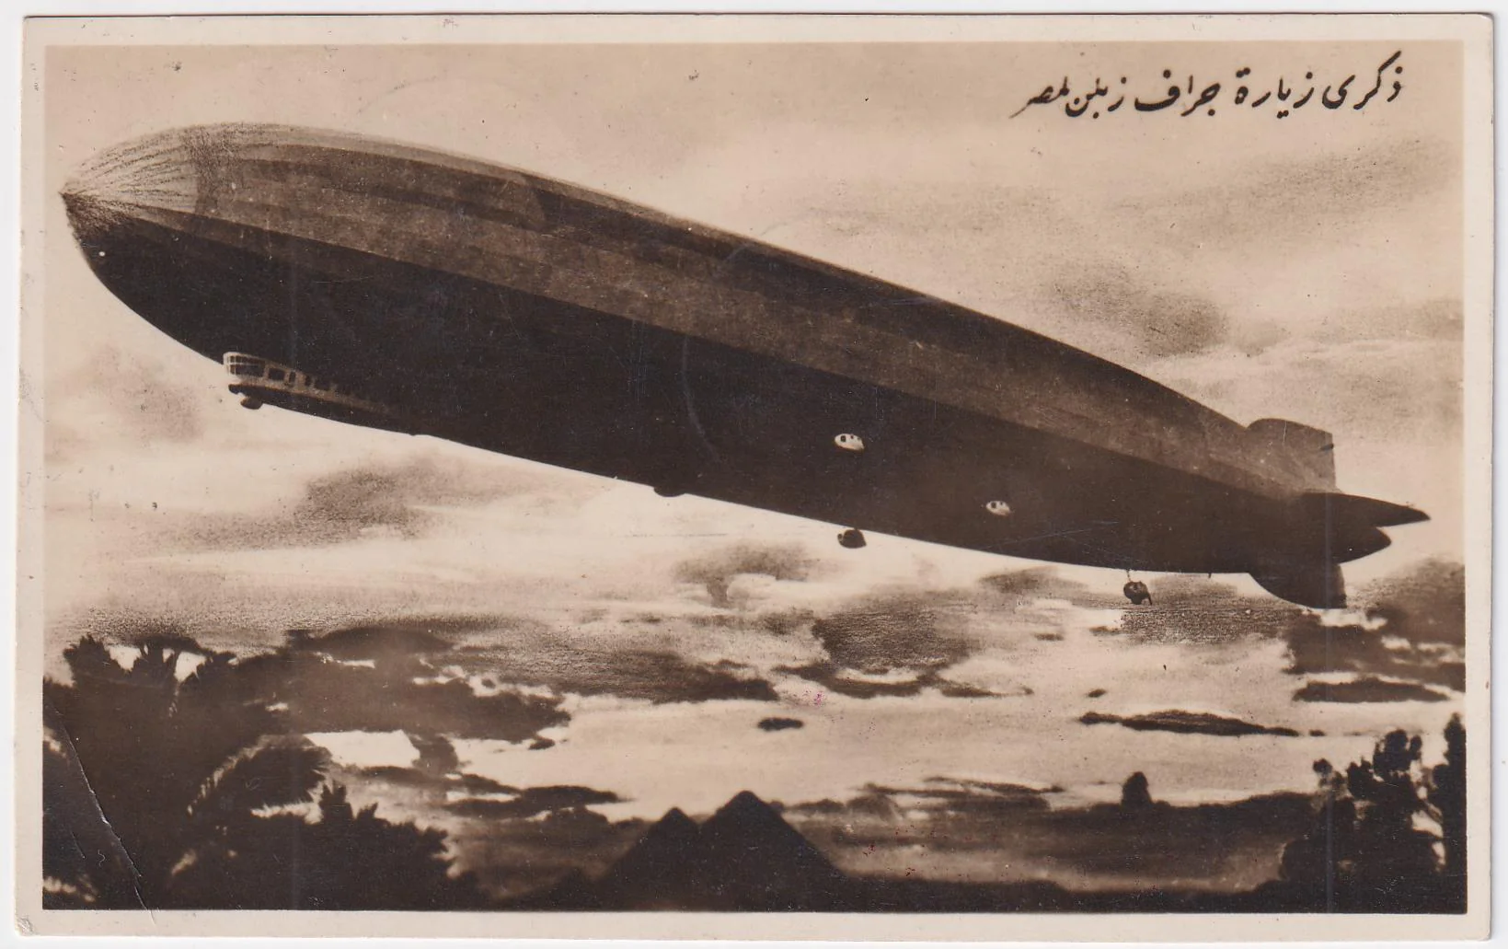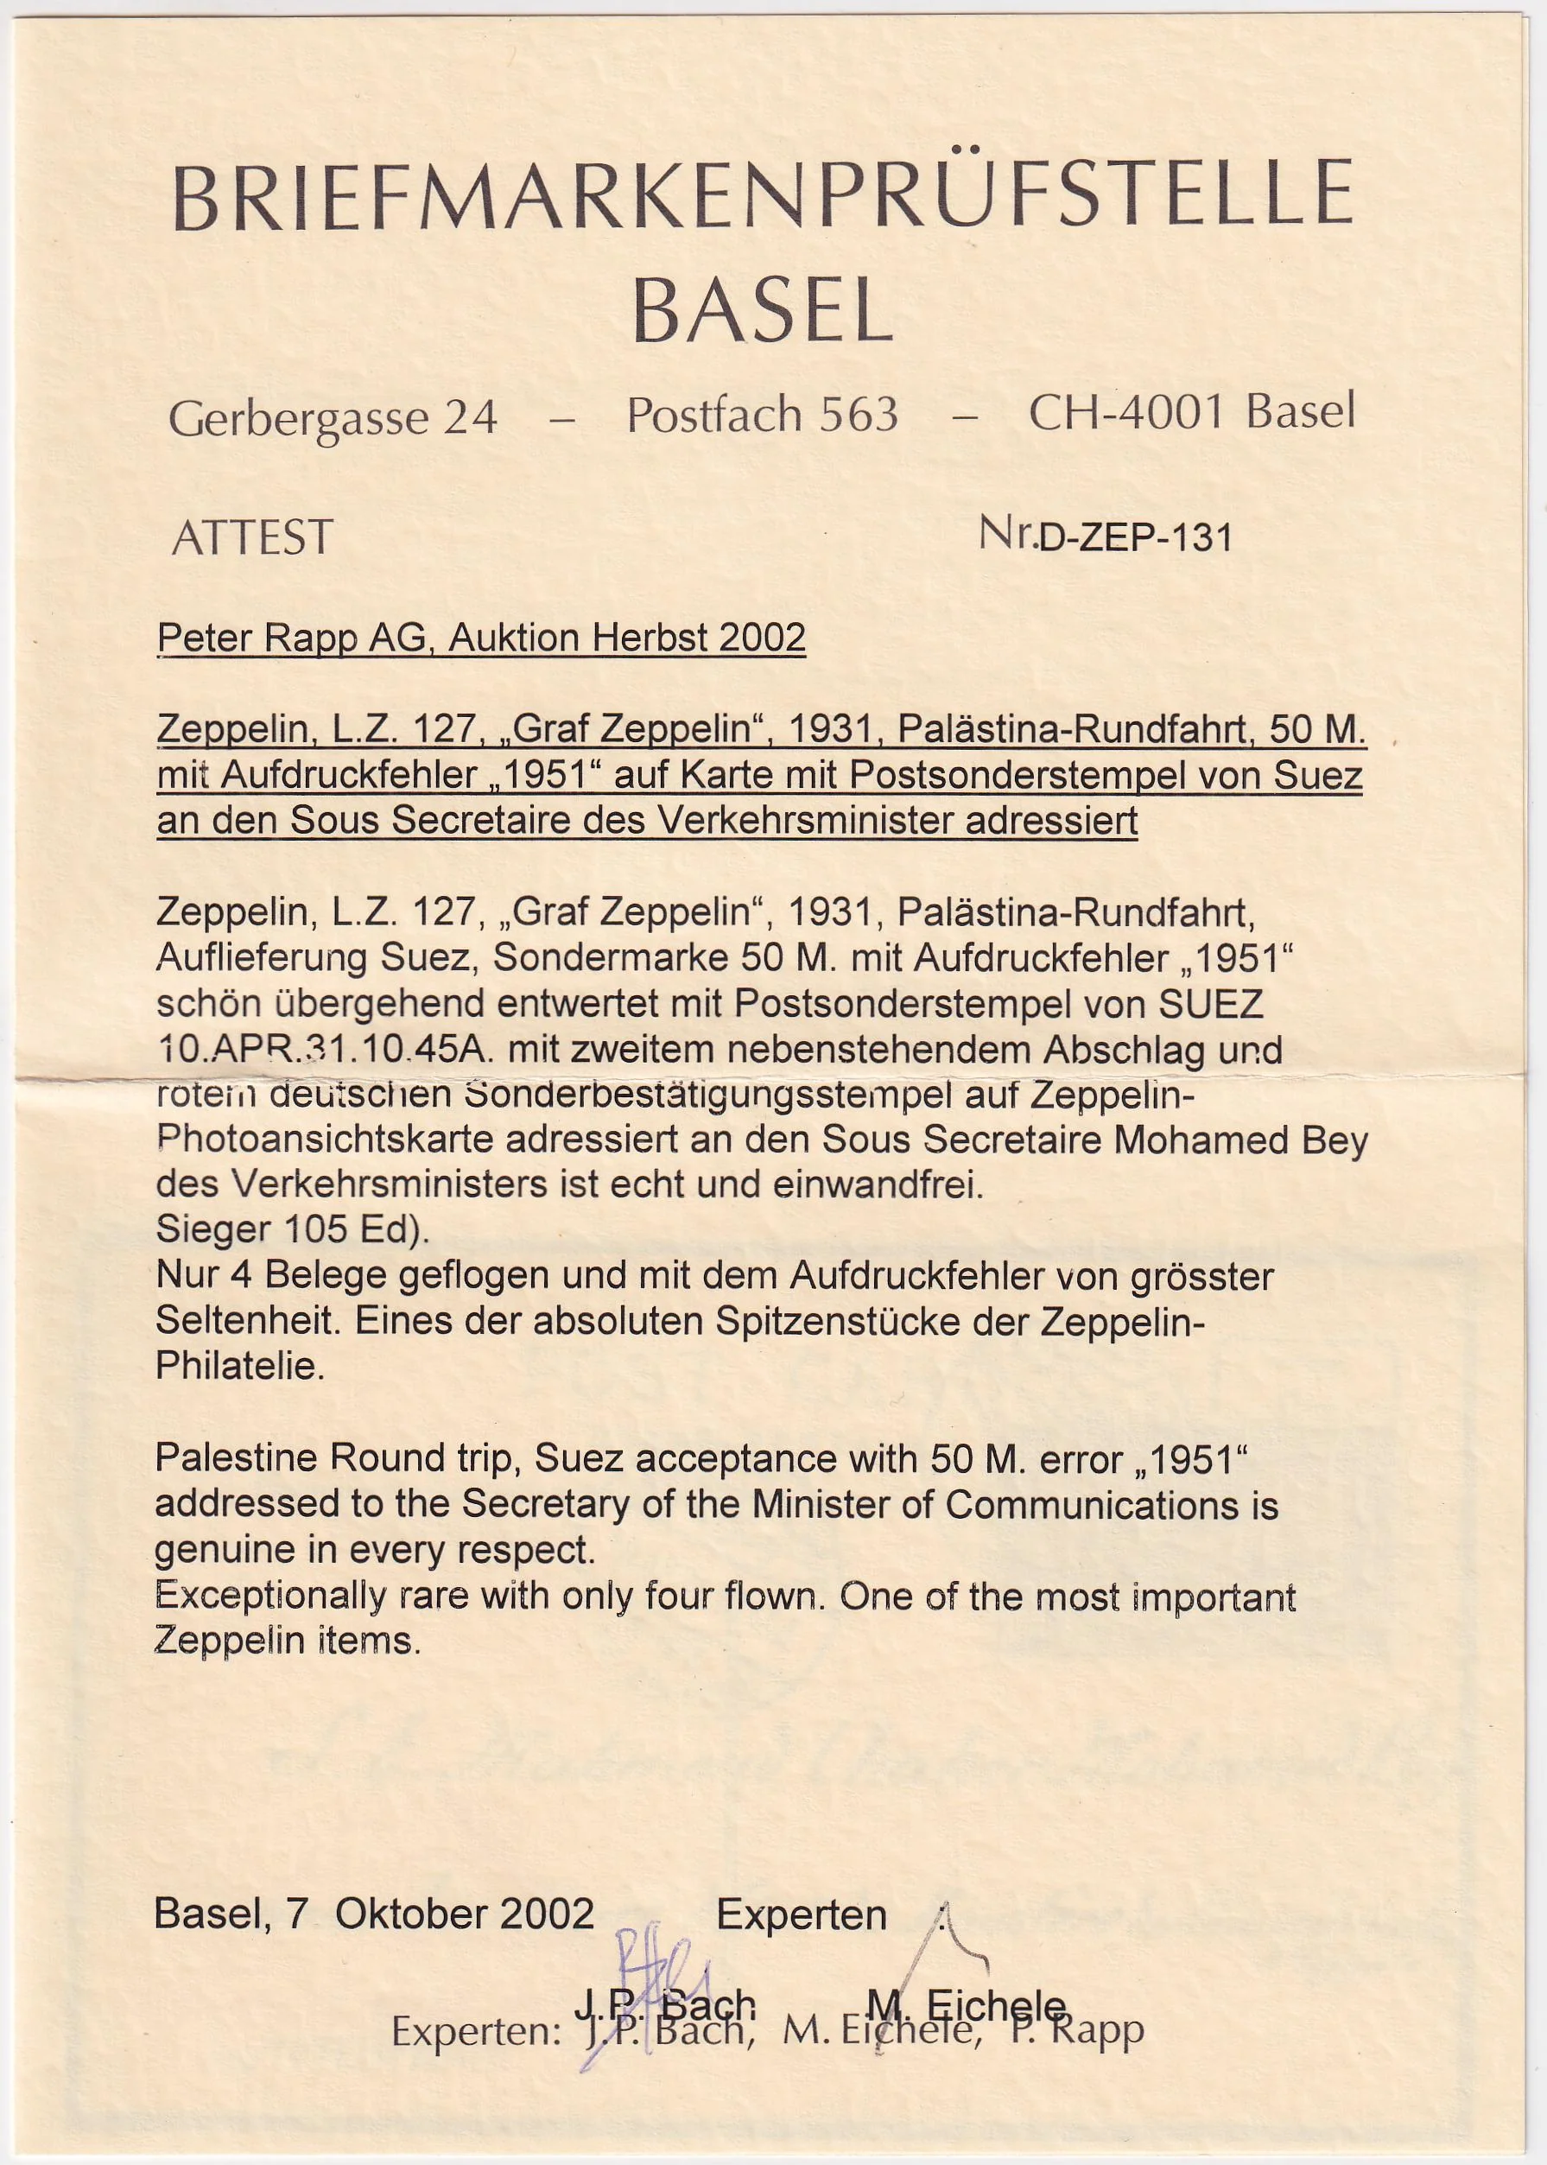
Egypt 1931 (Apr 10) Palestine Round Trip with 50m "1951" Error. item 36627 PC of Zeppelin in flight with Suez acceptance, addressed to the Secretary of the Minister of Communications and is genuine in every respect. Sieger €12,500. + 100% premium for the error. The previous owner pad 18,000 Sfr (+ commission) in Rapp 2022 auction. Only four flown! One of the great rarities if Zeppelin philately. Bach/Eichele certificate. net $16,000.00 (not included in any promotional sale)
Item 21574 US 1933 (Nov 1). 1998 Irish Crash Airmail Catalogue # 34.05.15.3 variety. Cancelled in NY Nov 1, 1933 then Brooklyn Jan 4, 1934, Brooklyn May 13, 1934 and Ireland May 15, London Jun 7, 1934 and NY Jun 16.Signed by Cesare Sabelli and George Pond, the pilots. $850.00

